Nixon Addresses the Nation about the Energy Crisis
Good evening:
Three weeks ago, I spoke to you about the national energy crisis and our policy for meeting it. Tonight I want to talk with you again to report on our progress and to announce further steps we must take to carry out our energy policy.
When I spoke to you earlier, I indicated that the sudden cutoff of oil from the Middle East had turned the serious energy shortages we expected this winter into a major energy crisis. That crisis is now being felt around the world, as other industrialized nations have also suffered from cutbacks in oil from the Middle East.
Shortages in Europe, for example, are far more critical than they are in the United States. Already seven European nations have imposed a ban on Sunday driving. Fortunately, the United States is not as dependent upon Middle Eastern oil as many other nations. We will not have a ban on Sunday driving, but as you will hear later, we are going to try to limit it. Nevertheless, we anticipate that our shortages could run as high as 17 percent. This means that we must immediately take strong, effective countermeasures.
In order to minimize disruptions in our economy, I asked on November 7 that all Americans adopt certain energy conservation measures to help meet the challenge of reduced energy supplies. These steps include reductions in home heating, reductions in driving speeds, elimination of unnecessary lighting. And the American people, all of you, you have responded to this challenge with that spirit of sacrifice which has made this such a great nation.
And upon the action and the recommendation of this group, I am announcing tonight the following steps to meet the energy crisis:
First, to increase the supply of heating oil that will be available this winter, we must adjust production schedules and divert petroleum which might normally go for the production of gasoline to the production of more heating oil.
as a second step, I am asking tonight that all gasoline filling stations close down their pumps between 9 p.m. Saturday night and midnight Sunday every weekend, beginning December 1. We are requesting that this step be taken voluntarily now.
Upon passage of the emergency energy legislation before the Congress, gas stations will be required to close during these hours. This step should not result in any serious hardship for any American family. It will, however, discourage long-distance driving during weekends. It will mean perhaps spending a little more time at home.
This savings alone is only a small part of what we have to conserve to meet the total gasoline shortage. We can achieve substantial additional savings by altering our driving habits. While the voluntary response to my request for reduced driving speeds has been excellent, it is now essential 'that we have mandatory and full compliance with this important step on a nationwide basis.
And therefore, the third step will be the establishment of a maximum speed limit for automobiles of 50 miles per hour nationwide as soon as our emergency energy legislation passes the Congress. We expect that this measure will produce a savings of 200,000 barrels of gasoline per day.

The fourth step we are taking involves our jet airliners. There will be a phased reduction of an additional 15 percent in the consumption of jet fuel for passenger flights bringing the total reduction to approximately 25 percent.
Let me conclude by restating our overall objective. It can be summed up in one word that best characterizes this Nation and its essential nature. That word is "independence." From its beginning 200 years ago, throughout its history, America has made great sacrifices of blood and also of treasure to achieve and maintain its independence. In the last third of this century, our independence will depend on maintaining and achieving self-sufficiency in energy.
What I have called Project Independence 1980 is a series of plans and goals set to insure that by the end of this decade, Americans will not have to rely on any source of energy beyond our own.
As far as energy is concerned, this means we will hold our fate and our future in our hands alone. As we look to the future, we can do so, confident that the energy crisis will be resolved not only for our time but for all time. We will once again have plentiful supplies of energy which helped to build the greatest industrial nation and one of the highest standards of living in the world.
The capacity for self-sufficiency in energy is a great goal. It is also an essential goal, and we are going to achieve it.
Tonight I ask all of you to join together in moving toward that goal, with the spirit of discipline, self-restraint, and unity which is the cornerstone of our great and good country.

Gas Station in Kansas City, Missouri

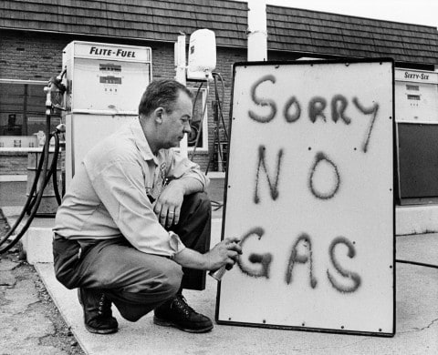

Oil Prices in the U.S. 1970-1995

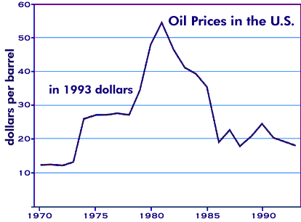

Effects of the Embargo

The oil embargo is widely blamed for causing the 1973-1975 recession. But U.S. government policies really caused the recession and the stagflation that accompanied it. They included Nixon's wage-price controls and the Federal Reserve's stop-go monetary policy. Wage-price controls forced companies to keep wages high, which meant businesses laid off workers to reduce costs. At the same time, they couldn't lower prices to stimulate demand. It had fallen when people lost their jobs.
To make matters worse, the Fed raised and lowered interest rates so many times that businesses were unable to plan for the future. As a result, companies kept prices high which worsened inflation. They were afraid to hire new workers, worsening the recession. But Fed officials learned this lesson from the history of U.S. recessions. Since then, they've been consistent in their actions. More important, they clearly signal their intentions well ahead of time.
The oil embargo aggravated inflation, already at 10 percent for some commodities, by raising oil prices.

It came at a vulnerable time for the U.S. economy. Domestic oil producers were running at full tilt. They were unable to produce more oil to make up the slack. Furthermore, U.S. oil production had declined as a percent of world output.
It also worsened the recession by shaking consumer confidence. People were forced to change habits, making it feel like a crisis that the government tried unsuccessfully to resolve. This lack of confidence made people spend less.

Nixon Resigns the Presidency
In all the decisions I have made in my public life, I have always tried to do what was best for the Nation. Throughout the long and difficult period of Watergate, I have felt it was my duty to persevere, to make every possible effort to complete the term of office to which you elected me.
In the past few days, however, it has become evident to me that I no longer have a strong enough political base in the Congress to justify continuing that effort. As long as there was such a base, I felt strongly that it was necessary to see the constitutional process through to its conclusion, that to do otherwise would be unfaithful to the spirit of that deliberately difficult process and a dangerously destabilizing precedent for the future.
But with the disappearance of that base, I now believe that the constitutional purpose has been served, and there is no longer a need for the process to be prolonged.
I would have preferred to carry through to the finish whatever the personal agony it would have involved, and my family unanimously urged me to do so. But the interest of the Nation must always come before any personal considerations.
I have never been a quitter. To leave office before my term is completed is abhorrent to every instinct in my body. But as President, I must put the interest of America first. America needs a full-time President and a full-time Congress, particularly at this time with problems we face at home and abroad.
To continue to fight through the months ahead for my personal vindication would almost totally absorb the time and attention of both the President and the Congress in a period when our entire focus should be on the great issues of peace abroad and prosperity without inflation at home.
Therefore, I shall resign the Presidency effective at noon tomorrow. Vice President Ford will be sworn in as President at that hour in this office.
When I first took the oath of office as President 51/2 years ago, I made this sacred commitment, to "consecrate my office, my energies, and all the wisdom I can summon to the cause of peace among nations."
I have done my very best in all the days since to be true to that pledge. As a result of these efforts, I am confident that the world is a safer place today, not only for the people of America but for the people of all nations, and that all of our children have a better chance than before of living in peace rather than dying in war.
This, more than anything, is what I hoped to achieve when I sought the Presidency. This, more than anything, is what I hope will be my legacy to you, to our country, as I leave the Presidency.
To have served in this office is to have felt a very personal sense of kinship with each and every American. In leaving it, I do so with this prayer: May God's grace be with you in all the days ahead.
Excerpts from Carl Bernstein and Bob Woodward’s book All the President Men

“June 17, 1972. Nine o'clock Saturday morning. Early for the telephone. Woodward fumbled for the receiver and snapped awake. The city editor of the Washington Post was on the line. Five men had been arrested earlier that morning in a burglary attempt at Democratic headquarters, carrying photographic equipment and electronic gear. Could he come in?”
― Carl Bernstein, All the President's Men

“It was 9:30 P.M., just an hour from deadline for the second edition. Woodward began typing:
A $25,000 cashier's check, apparently earmarked for the campaign chest of President Nixon, was deposited in April in the bank account of Bernard L. Barker, one of the five men arrested at the break-in and alleged bugging attempt at Democratic National Committee headquarters here June 17.
The last page of copy was passed to Sussman just at the deadline. Sussman set his pen and pipe down on his desk and turned to Woodward. 'We've never had a story like this,' he said. 'Just never.'
-- Carl Bernstein, Bob Woodward”
― Carl Bernstein, All the President's Men

Political Cartoon Nixon and the Missing Tapes

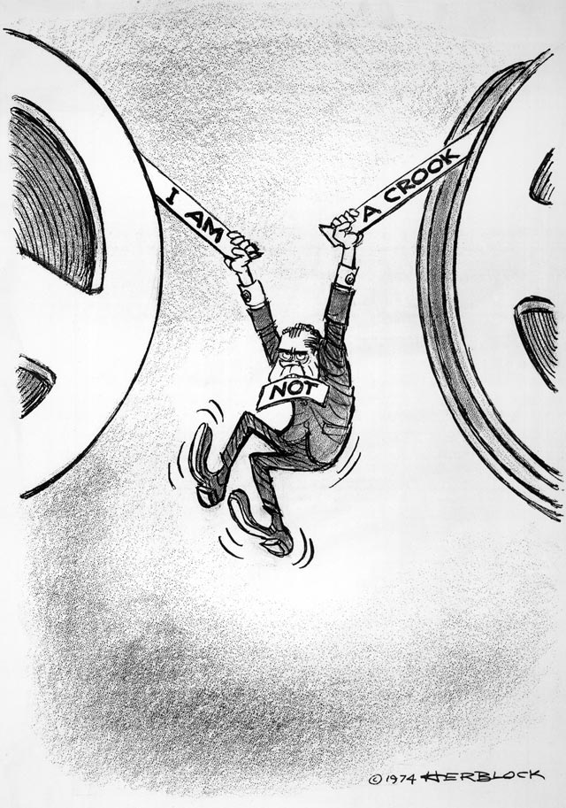

Political Cartoon, Nixon and Watergate

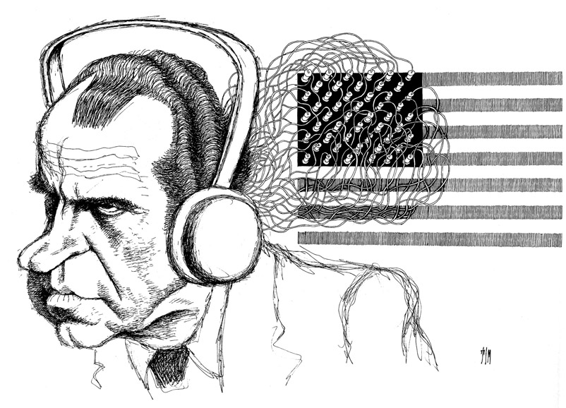

Summary of Stagflation

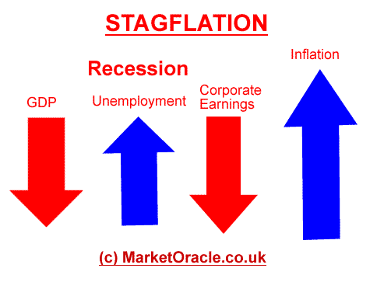

Graph example of Stagflation

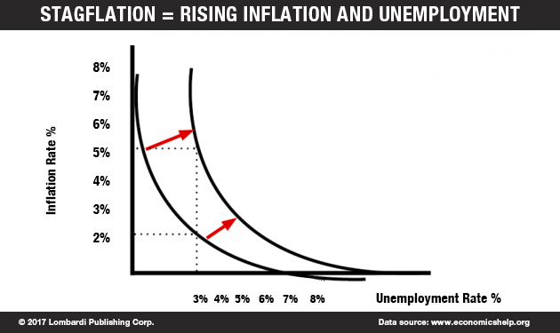

Stagflation of the 1970s
The word stagflation didn't even exist until the 1970s. From 1958 to 1973, the United States experienced what's known as the "Post-War Boom." Gross annual products in Western nations grew by an average of 5 percent annually, fueling a slow but steady rise in prices (inflation) over the same period [source: Cleveland].
So why did things go sour in the 1970s? It turns out that the Federal Reserve's monetary policy during the boom years of the late '50s and '60s was unsustainable.

President Carter’s Solution to Stagflation

President Carter was faced with these problems when he took office in 1977. Despite contrary belief, Carter is responsible for strong economic growth of the nation. Though the unemployment rate in the 70s proved to be far above those listed in the 50s or 60s, the rate during Carter’s administration was lower than in either the administrations of Ford or Reagan. Inflation during Carter’s year averaged 8 percent, but the average was 9 percent for one year in the Carter administration and two consecutive years for Ford. Also, Carter showed the strongest growth in real GNP out of Reagan, Eisenhower, Nixon, or Ford with a 3.1 percent.
As a conservative Democrat in the context of fiscal policy, president Carter focused on creating a balanced budget and warned the hazards of unnatural price increases. In fact, the budget deficit can be used the measure the successfulness of fiscal policy. In the postwar era, increasing budget deficit is inevitable though proved to be held at a moderate rate during the Carter administration. While during Ford’s presidency the deficit averaged $103.3 billion and during Carter’s, $153.1 billion, the average was $74.7 billion in the Carter years.

Carter may not have had extreme fiscal policies directed at combatting the growing inflation, though he was completely cognizant of the inflation situation. He did his best to bring back the confidence in to the American dollar—which, after all, has no value and is only backed by faith.
Much of the failures to strengthen the economy can be credited to the already bad times that Carter was placed in when he first started office. The poor economic state was caused by the postwar baby-boom, which brought an influx of eager workers. Low unemployment was the incentive for Keynesian economists to increase a healthy rate of inflation, but the improper model of the Phillips Curve hid the truth about wage-price spiral. By increasing government spending in the 60s, prices rose rapidly. With price increases, workers expected more pay, purchasing more goods in the short term. Stagflation arrived just in time for Carter’s first day in office by the 70s. A situation he was faced with created a negative view of Carter that has wrongfully been illustrated. Carter was not at fault for the stagflation experienced in the 70s

Cartoon Example of Stagflation

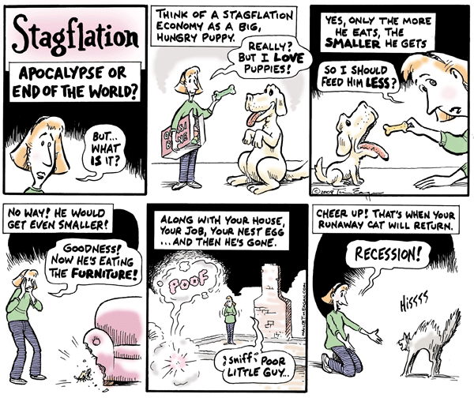

CNN: The Age of Sex

To borrow a cliché, the 1970s was all about sex, drugs and rock and roll. But arguably, it was the sex part that had the most enduring and profound effect on American society.
The 1970s saw the convergence of several phenomena related to sex, sexuality and gender. There was the women's liberation movement, in which women and girls who had been long told they were the inferior sex finally took to the streets, the courts and the voting booths to assert their equality.

There also was sexual liberation, which had something to do with women liberating themselves in the bedroom, too, but had as much to do with loosening norms around sex. In 1960, half of 19-year-old women who were unmarried had not yet had sex. By the late 1980s, as Nancy Cohen pointed out, two-thirds of all women had done the deed by age 18.
Cohen also noted that the invention of the birth control pill in the 1960s helped pave the way. Within five years after the first pill went on the market in 1960, 6 million American women were taking it. These women and others, and their male partners, entered the next decade literally with a radically different experience of sex and freedom. The year 1972 alone saw the publication of such groundbreaking books as "The Joy of Sex" and "Open Marriage."
The '70s also brought nonheterosexual sex into the spotlight. In 1969, when a gay bar in New York was raided by police, protests erupted and what became known as the Stonewall Riots was the formative moment of the gay rights movement that would continue to grow into the next decades.
For gay, lesbian, bisexual and transgender Americans, the 1970s was an era of increasing awakening and visibility, as well as backlash and persecution. In 1970, the first gay pride parade was held to commemorate the Stonewall Riots, and in 1973, the American Psychiatric Association finally saw fit to remove homosexuality from its official list of mental disorders.

Divorce Rate and Birth Control Use Graph: 1955-2010

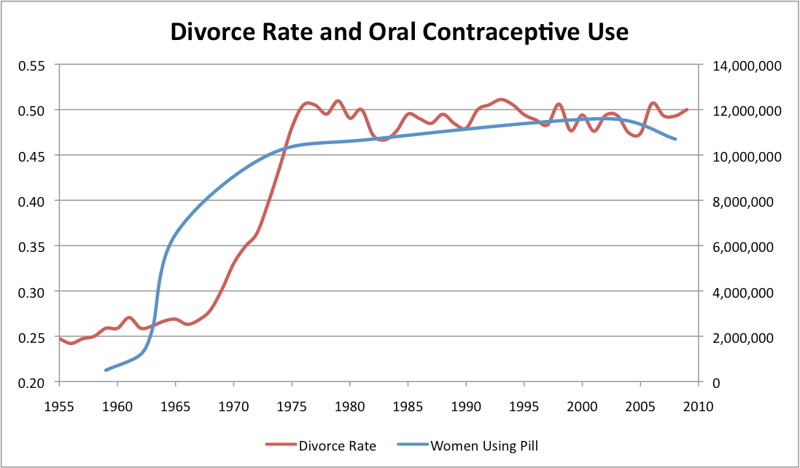

Roe v. Wade Summary and Impact
A shift began in the 1960s. Beginning with Colorado in 1967, thirteen states opened access to abortion. Several states restricted the procedure, while thirty-one states allowed it only to save the life of the mother. A Texas woman, using the name Jane Roe, challenged her state law and her case eventually went to the Supreme Court.
The Constitution does not list a right to privacy. The Court has held, however, that Bill of Rights protections of free speech, assembly, and religious exercise (First Amendment), along with freedom from forced quartering of troops (Third), unreasonable searches and seizures (Fourth), and forced self-incrimination (Fifth) create “zones of privacy.” Further, the Ninth Amendment’s protection of unenumerated rights could be said to protect privacy. These “zones,” the Court held, are places into which the government cannot unreasonably intrude. Roe claimed that the law robbed her of her right to privacy as protected by the combination of Bill of Rights amendments, and of her liberty as protected by the Due Process Clause of the Fourteenth Amendment.
The Court agreed with Roe and held that “the right to privacy includes the abortion decision.” The Court emphasized that abortion rights were not absolute. “The pregnant woman cannot be isolated in her privacy…[I]t is reasonable and appropriate for a State to decide that at some point in time another interest, that of health of the mother or that of potential human life, becomes significantly involved.” States could not ban abortion during the first trimester, but as pregnancy progressed, the Court held, the state’s interest in protecting life could begin to outweigh the woman’s liberty. Therefore states could restrict the procedure later in pregnancy.
The decision in Roe v. Wade continues to be one of the most controversial the Court has ever issued. Demonstrations are frequently held on the anniversary of the decision—some in protest and some in support. In subsequent cases, the Court has upheld laws requiring waiting periods and other similar restrictions on abortion, even within the first trimester.
Harvey Milk Speech
So much for that. Why are we here? Why are gay people here? And what's happening? What's happening to me is the antithesis of what you read about in the papers and what you hear about on the radio. You hear about and read about this movement to the right. That we must band together and fight back this movement to the right. And I'm here to go ahead and say that what you hear and read is what they want you to think because it's not happening. The major media in this country has talked about the movement to the right so the legislators think that there is indeed a movement to the right and that the Congress and the legislators and the city councils will start to move to the right the way the major media want them. So they keep on talking about this move to the right.
So let's look at 1977 and see if there was indeed a move to the right. In 1977, gay people had their rights taken away from them in Miami. But you must remember that in the week before Miami and the week after that, the word homosexual or gay appeared in every single newspaper in this nation in articles both pro and con. In every radio station, in every TV station and every household. For the first time in the history of the world, everybody was talking about it, good or bad. Unless you have dialogue, unless you open the walls of dialogue, you can never reach to change people's opinion. In those two weeks, more good and bad, but more about the word homosexual and gay was written than probably in the history of mankind. Once you have dialogue starting, you know you can break down prejudice. In 1977 we saw a dialogue start. In 1977, we saw a gay person elected in San Francisco. In 1977 we saw the state of Mississippi decriminalize marijuana. In 1977, we saw the convention of conventions in Houston. And I want to know where the movement to the right is happening.

Like every other group, we must be judged by our leaders and by those who are themselves gay, those who are visible. For invisible, we remain in limbo--a myth, a person with no parents, no brothers, no sisters, no friends who are straight, no important positions in employment. A tenth of the nation supposedly composed of stereotypes and would-be seducers of children--and no offense meant to the stereotypes. But today, the black community is not judged by its friends, but by its black legislators and leaders. And we must give people the chance to judge us by our leaders and legislators. A gay person in office can set a tone, con command respect not only from the larger community, but from the young people in our own community who need both examples and hope.
The first gay people we elect must be strong. They must not be content to sit in the back of the bus. They must not be content to accept pablum. They must be above wheeling and dealing. They must be--for the good of all of us--independent, unbought. The anger and the frustrations that some of us feel is because we are misunderstood, and friends can't feel the anger and frustration. They can sense it in us, but they can't feel it. Because a friend has never gone through what is known as coming out. I will never forget what it was like coming out and having nobody to look up toward. I remember the lack of hope--and our friends can't fulfill it.
So if there is a message I have to give, it is that I've found one overriding thing about my personal election, it's the fact that if a gay person can be elected, it's a green light. And you and you and you, you have to give people hope. Thank you very much.

Political Cartoon of anti-ERA activist Phyllis Schlafly

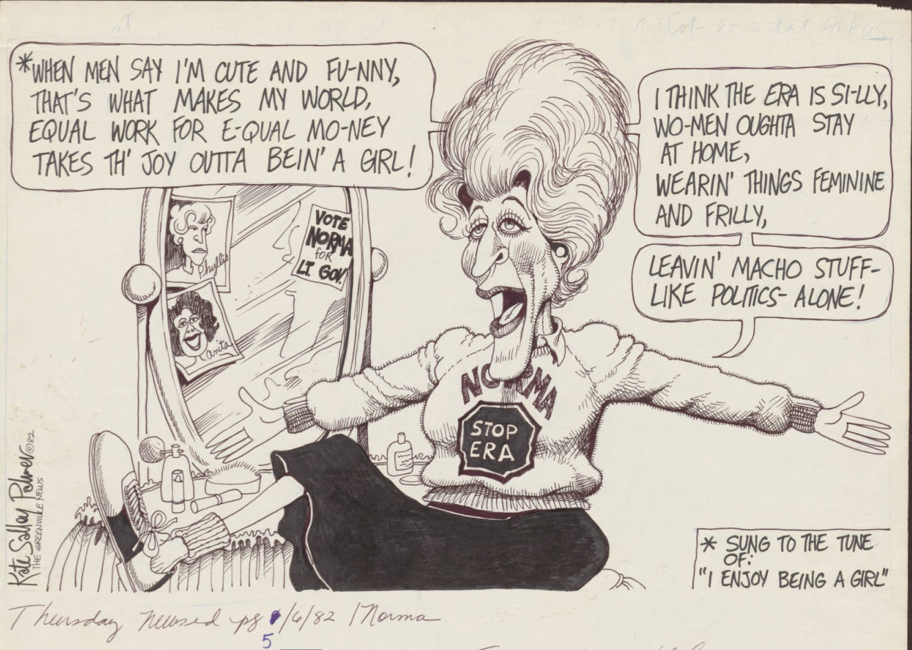

Quotes from Phyllis Schlafly on the role of women and the ERA

"Since the women are the ones who bear the babies and there's nothing we can do about that, our laws and customs then make it the financial obligation of the husband to provide the support," she said in 1973. "It is his obligation and his sole obligation. And this is exactly and precisely what we will lose if the Equal Rights Amendment is passed."

"What that amendment would do is to make all laws sex-neutral. Well, the typical, classic law that is not sex-neutral is the draft registration law. And we were still in the Vietnam War in 1972.
"I had sons and daughters about age 18. My daughters thought this was the craziest thing they ever heard. You're going to have a new amendment for women? And the first thing is they'll have to sign up for the draft like their brothers. Now, that was an unsalable proposition."

Growth, Inflation and unemployment, 1970-1989

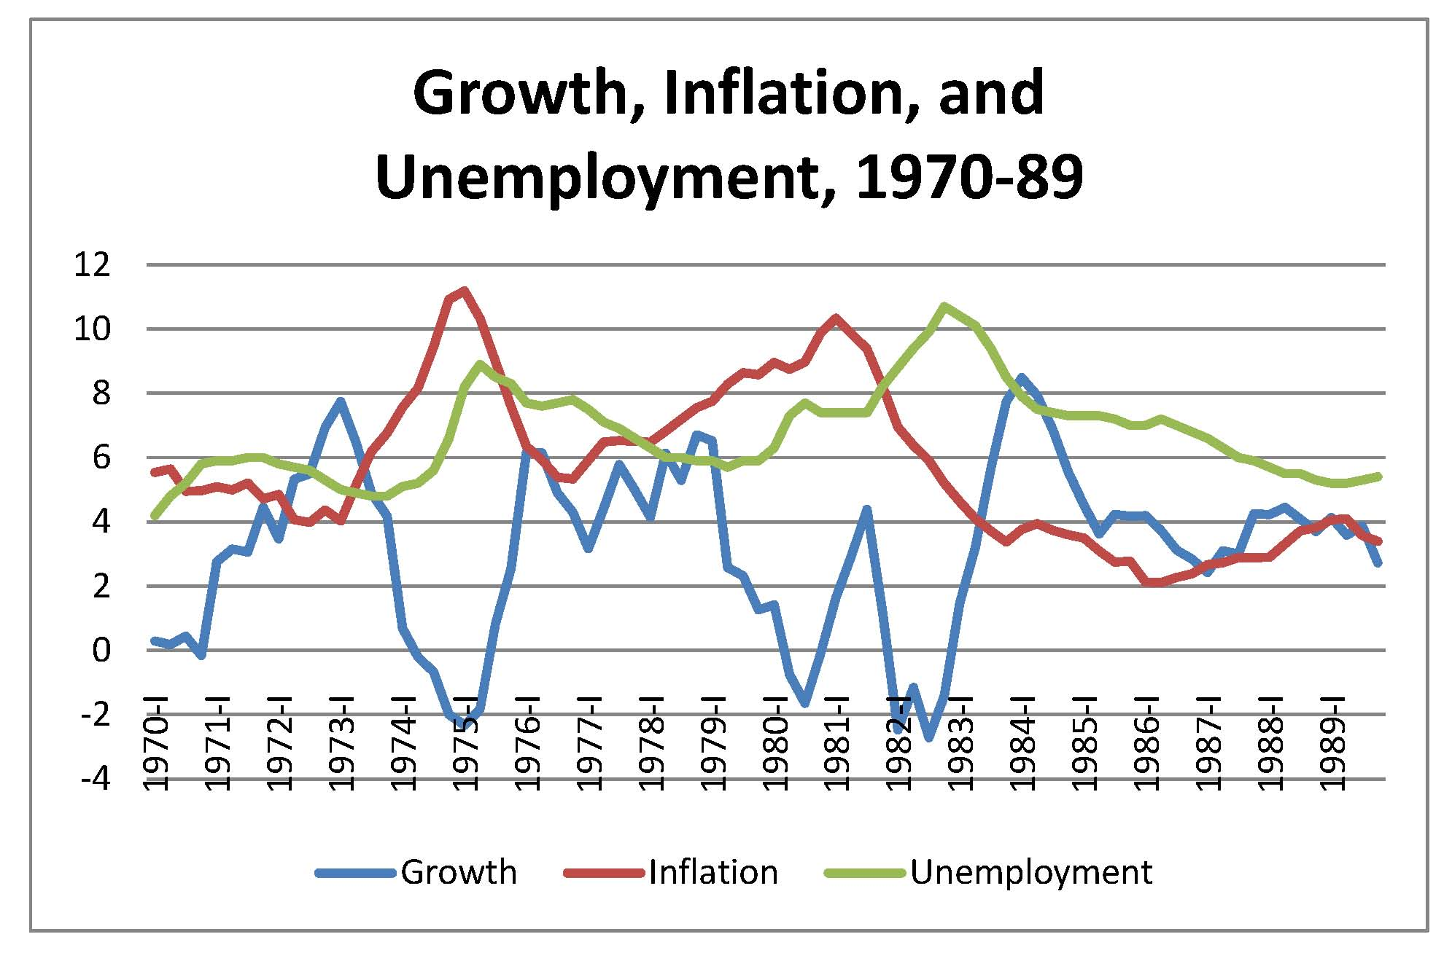

Quotes from Evangelical Leader Billy Graham

“the greatest legacy one can pass on to one’s children is not money or material things accumulated in one’s life, but rather a legacy of character and faith

The influence of a mother upon the lives of her children cannot be measured. They know and absorb her example and attitudes at home when it comes to questions of honesty, temperance, kindness, and industry

Photo of Billy Graham’s Speech

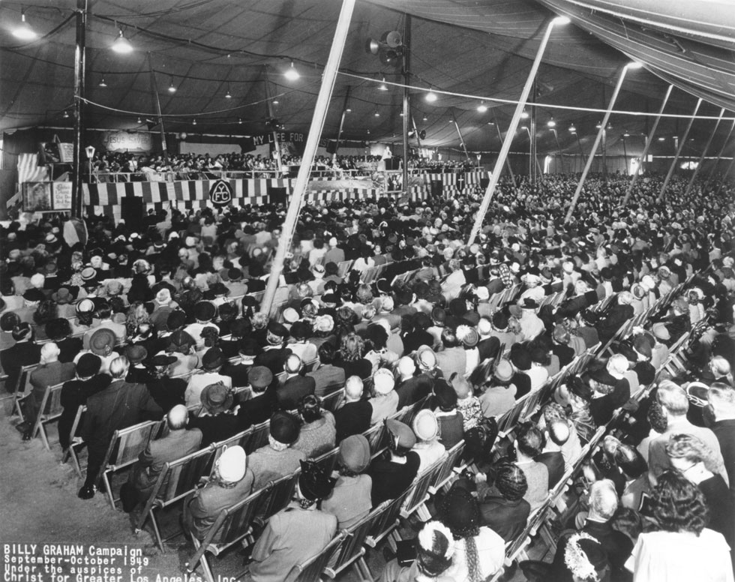

Mission Statement for Focus on the Family established 1977
Focus on the Family is a global Christian ministry dedicated to helping families thrive. We provide help and resources for couples to build healthy marriages that reflect God's design, and for parents to raise their children according to morals and values grounded in biblical principles.
We're here to come alongside families with relevance and grace at each stage of their journey. We support families as they seek to teach the ir children about God and His beautiful design for the family, protect themselves from the harmful influences of culture and equip themselves to make a greater difference in the lives of those around them.
No matter who you are, what you're going through or what challenges your family may be facing, we're here to help. With practical resources - like our 1-800 Family Help line, counseling and websites – we're committed to providing trustworthy, biblical guidance and support.

