Document 1
Jacob Riis, 1890

Today, what is a tenement? "It is generally a brick building from four to six stories high on the street, frequently with a store on the first floor which, when used for the sale of liquor, has a side opening for the benefit of the inmates and to evade the Sunday law; four families occupy each floor, and a set of rooms consists of one or two dark closets, used as bedrooms, with a living room twelve feet by ten. The staircase is too often a dark well in the center of the house, and no direct through ventilation is possible, each family being separated from the other by partitions. Frequently the rear of the lot is occupied by another building of three stories high with two families on a floor."
It no longer excites even passing attention, when the Sanitary police report counting 101 adults and 91 children in a Crosby Street House....Or when a midnight inspection in Mulbury Street unearths a hundred and fifty "lodgers" sleeping on filthy floors in two buildings....The tenements today are New York, harboring three-fourths of its population....

Document 2
Jacob Riis, How the Other Half Lives
The real foundlings, the children of the gutter that are picked up by the police, are the city's wards. In midwinter, when the poor shiver in their homes, and in the dog-days when the fierce heat and foul air of the tenements smother their babies by thousands, they are found, sometimes three and four in a night, in hallways, in areas and on the doorsteps of the rich, with whose comfort in luxurious homes the wretched mother somehow connects her own misery. Perhaps, as the drowning man clutches at a straw, she hopes that these happier hearts may have love to spare even for her little one. In this she is mistaken. Unauthorized babies especially are not popular in the abodes of the wealthy. It never happens outside of the story-books that a baby so deserted finds home and friends at once. Its career, though rather more official, is less romantic, and generally brief. After a night spent at Police Headquarters it travels up to the Infants' Hospital on Randall's Island in the morning, fitted out with a number and a bottle, that seldom see much wear before they are laid aside for a fresh recruit. Few outcast babies survive their desertion long. Murder is the true name of the mother's crime in eight cases out of ten. Of 508 babies received at the Randall's Island Hospital last year 333 died, 65.55 per cent. But of the 508 only 170 were picked up in the streets, and among these the mortality was much greater, probably nearer ninety per cent., if the truth were told. . . . But many do not live to be officially registered as a charge upon the county. Seventy-two dead babies were picked up in the streets last year. Some of them were doubtless put out by very poor parents to save funeral expenses. In hard times the number of dead and live foundlings always increases very noticeably. But whether travelling by way of the Morgue or the Infants' Hospital, the little army of waifs meets, reunited soon, in the trench in the Potter's Field where, if no medical student is in need of a subject, they are laid in squads of a dozen.

Document 3
Charles Loring Brace, 1872

In most large cities...there are too many scattered efforts, aiming in a desultory manner at this and that particular evil, resulting from the condition of the children of the streets. There is no unity of plan and of work....So threatening is the danger in every populous town from the children who are neglected, that the best talent ought to be engaged to study their condition and devise their improvement....We would not breathe a word against the absolute necessity of Christianity in any scheme of thorough social reform....To attempt to prevent or cure the fearful moral diseases of our lowest classes without Christianity, is like trying to carry through a sanitary reform in a city without sunlight.

Document 4
Jane Addams

Never before in civilization have such numbers of young girls been suddenly released from the protection of the home and permitted to walk unattended upon city streets....Never before have such numbers of young boys earned money independently of the family life, and felt themselves free to spend it as they choose in the midst of vice deliberately disguised as pleasure....Let us know the modern city in its weakness and wickedness, and then seek to rectify and purify it until it shall be free at least from the grosser temptations which now beset the young people who are living in its tenement houses and working in its factories.

Document 5
Upton Sinclair, The Jungle

Jonas had told them how the meat that was taken out of pickle would often be found sour, and how they would rub it up with soda to take away the smell, and sell it to be eaten on free-lunch counters; also of all the miracles of chemistry which they performed, giving to any sort of meat, fresh or salted, whole or chopped, any color and any flavor and any odor they chose. In the pickling of hams they had an ingenious apparatus, by which they saved time and increased the capacity of the plant – a machine consisting of a hollow needle attached to a pump; by plunging this needle into the meat and working with his foot, a man could fill a ham with pickle in a few seconds. And yet, in spite of this, there would be hams found spoiled, some of them with an odor so bad that a man could hardly bear to be in the room with them. To pump into these the packers had a second and much stronger pickle which destroyed the odor – a process known to the workers as "giving them thirty per cent." Also, after the hams had been smoked, there would be found some that had gone to the bad. Formerly these had been sold as "Number Three Grade," but later on some ingenious person had hit upon a new device, and now they would extract the bone, about which the bad part generally lay, and insert in the hole a white-hot iron. After this invention there was no longer Number One, Two, and Three Grade – there was only Number One Grade. The packers were always originating such schemes – they had what they called "boneless hams," which were all the odds and ends of pork stuffed into casings; and "California hams," which were the shoulders, with big knuckle joints, and nearly all the meat cut out; and fancy "skinned hams," which were made of the oldest hogs, whose skins were so heavy and coarse that no one would buy them – that is, until they had been cooked and chopped fine and labeled "head cheese!"
It was only when the whole ham was spoiled that it came into the department of Elzbieta. Cut up by the two-thousand-revolutions-a-minute flyers, and mixed with half a ton of other meat, no odor that ever was in a ham could make any difference. There was never the least attention paid to what was cut up for sausage; there would come all the way back from Europe old sausage that had been rejected, and that was moldy and white – it would be dosed with borax and glycerine, and dumped into the hoppers, and made over again for home consumption. There would be meat that had tumbled out on the floor, in the dirt and sawdust, where the workers had tramped and spit uncounted billions of consumption germs. There would be meat stored in great piles in rooms; and the water from leaky roofs would drip over it, and thousands of rats would race about on it. It was too dark in these storage places to see well, but a man could run his hand over these piles of meat and sweep off handfuls of the dried dung of rats. These rats were nuisances, and the packers would put poisoned bread out for them; they would die, and then rats, bread, and meat would go into the hoppers together. This is no fairy story and no joke; the meat would be shoveled into carts, and the man who did the shoveling would not trouble to lift out a rat even when he saw one – there were things that went into the sausage in comparison with which a poisoned rat was a tidbit. There was no place for the men to wash their hands before they ate their dinner, and so they made a practice of washing them in the water that was to be ladled into the sausage. There were the butt-ends of smoked meat, and the scraps of corned beef, and all the odds and ends of the waste of the plants, that would be dumped into old barrels in the cellar and left there. Under the system of rigid economy which the packers enforced, there were some jobs that it only paid to do once in a long time, and among these was the cleaning out of the waste barrels. Every spring they did it; and in the barrels would be dirt and rust and old nails and stale water – and cartload after cartload of it would be taken up and dumped into the hoppers with fresh meat, and sent out to the public's breakfast. Some of it they would make into "smoked" sausage – but as the smoking took time, and was therefore expensive, they would call upon their chemistry department, and preserve it with borax and color it with gelatine to make it brown. All of their sausage came out of the same bowl, but when they came to wrap it they would stamp some of it "special," and for this they would charge two cents more a pound.

Document 6
City Official Visits Tenement in New York City

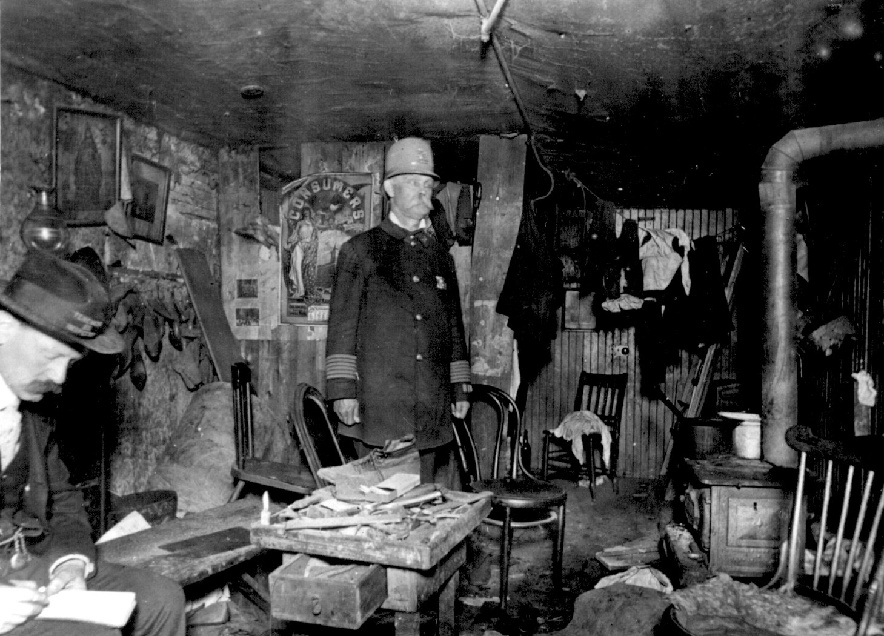

Document 7
Photograph of immigrant tenement, How the Other Half Lives

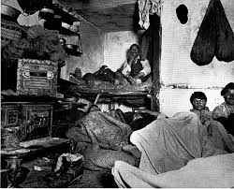

Document 8
Family in tenement home

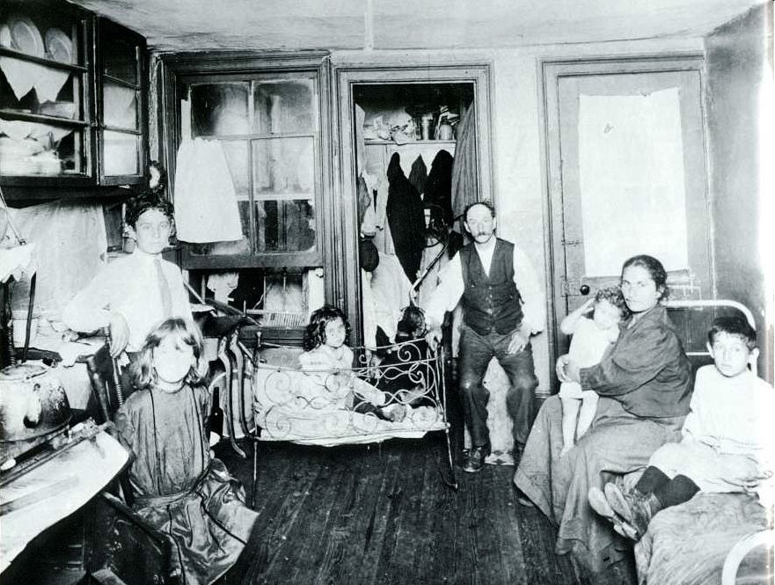

Document 9
Dance Hall, 1918

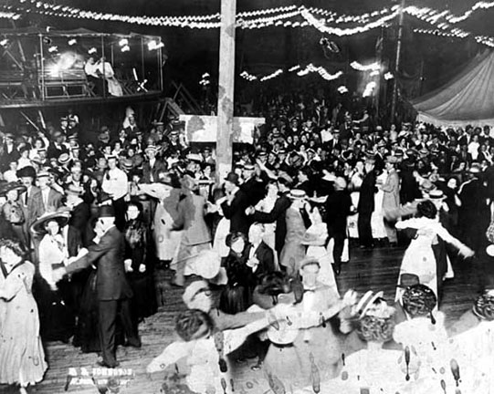

Document10
American Skyscraper, Chicago
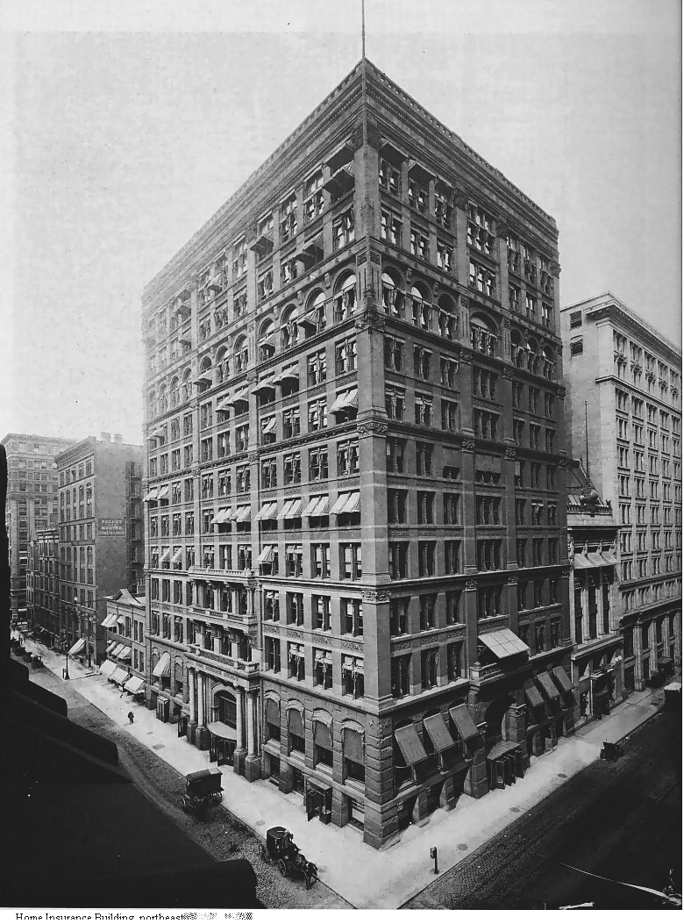

Document 11
Rural and urban Population numbers
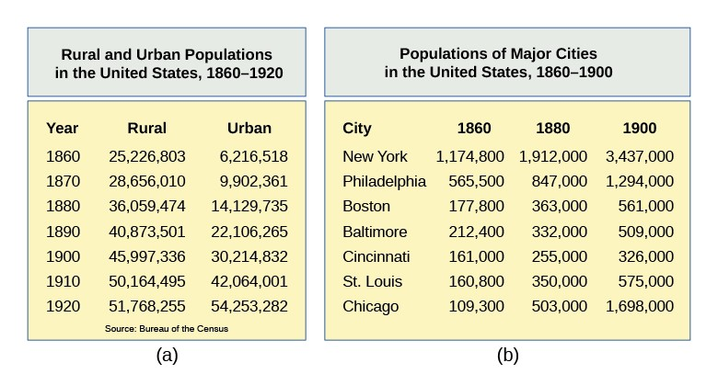

Document 12
American Steel Production 1865, 1900

Document 13
American Political Machines, Political Cartoon

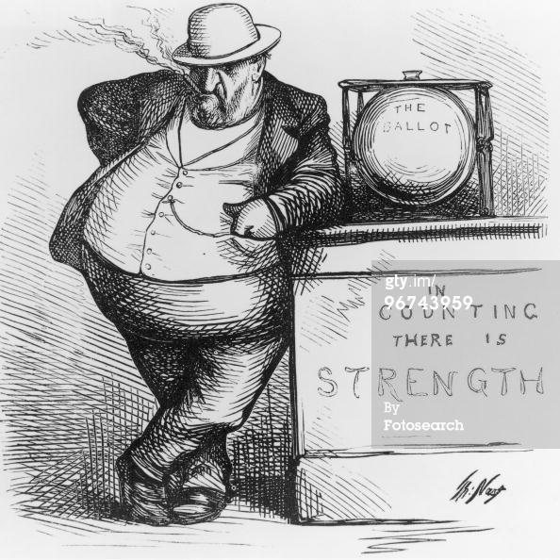

Document 14
Men’s Dinner in New York City, 1917
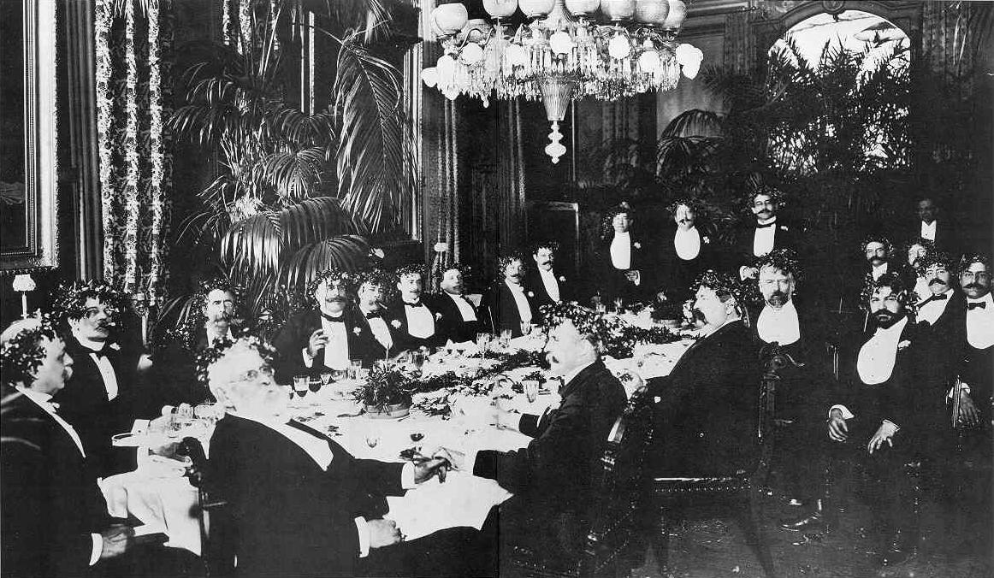

Document 15:
Mulberry Street, New York City 1914

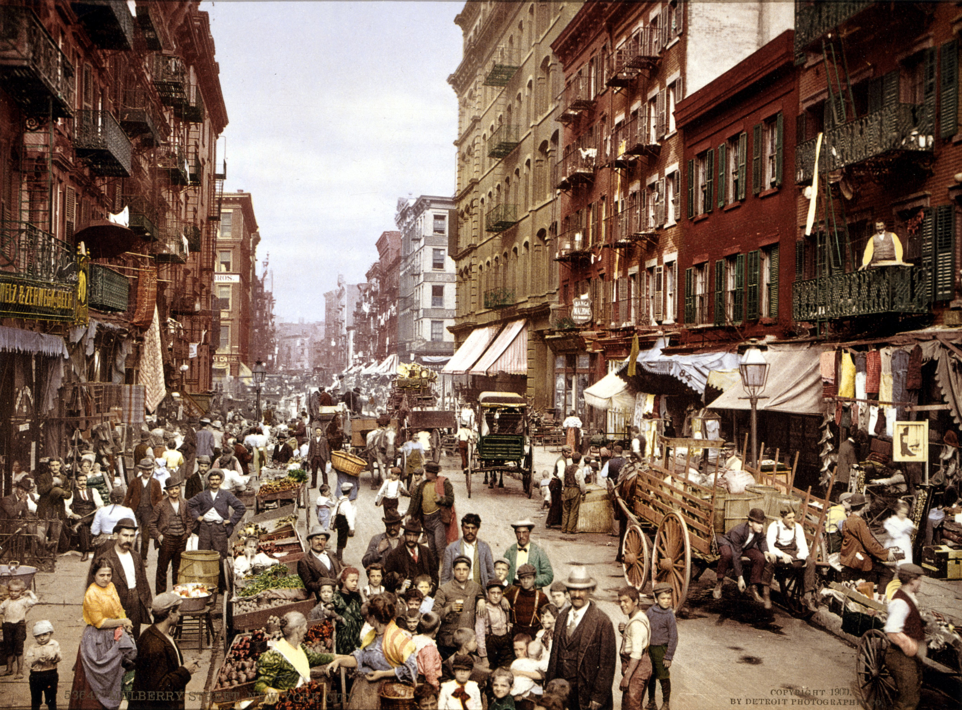

Document 15
“The Awakening” 1917
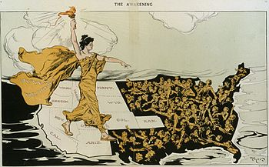

Document 16
Photograph of Cooney Island

