A Mitchell Palmer on the necessity of radical raids
In this brief review of the work which the Department of Justice has undertaken, to tear out the radical seeds that have entangled American ideas in their poisonous theories, I desire not merely to explain what the real menace of communism is, but also to tell how we have been compelled to clean up the country almost unaided by any virile legislation. Though I have not been embarrassed by political opposition, I have been materially delayed because the present sweeping processes of arrests and deportation of seditious aliens should have been vigorously pushed by Congress last spring. The failure of this is a matter of record in the Congressional files.
The anxiety of that period in our responsibility when Congress, ignoring the seriousness of these vast organizations that were plotting to overthrow the Government, failed to act, has passed. The time came when it was obviously hopeless to expect the hearty cooperation of Congress in the only way to stamp out these seditious societies in their open defiance of law by various forms of propaganda.
Like a prairie-fire, the blaze of revolution was sweeping over every American institution of law and order a year ago. It was eating its way into the homes of the American workmen, its sharp tongues of revolutionary heat were licking the altars of the churches, leaping into the belfry of the school bell, crawling into the sacred corners of American homes, seeking to replace marriage vows with libertine laws, burning up the foundations of society.
Robbery, not war, is the ideal of communism. This has been demonstrated in Russia, Germany, and in America. As a foe, the anarchist is fearless of his own life, for his creed is a fanaticism that admits no respect of any other creed. Obviously it is the creed of any criminal mind, which reasons always from motives impossible to clean thought. Crime is the degenerate factor in society.
Upon these two basic certainties, first that the “Reds” were criminal aliens and secondly that the American Government must prevent crime, it was decided that there could be no nice distinctions drawn between the theoretical ideals of the radicals and their actual violations of our national laws. An assassin may have brilliant intellectuality, he may be able to excuse his murder or robbery with fine oratory, but any theory which excuses crime is not wanted in America. This is no place for the criminal to flourish, nor will he do so long as the rights of common citizenship can be exerted to prevent him.
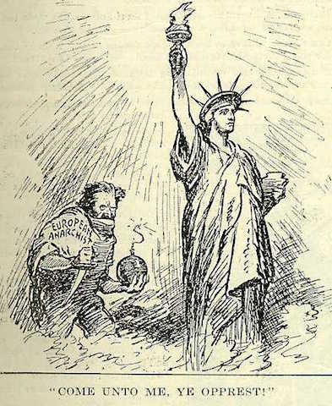

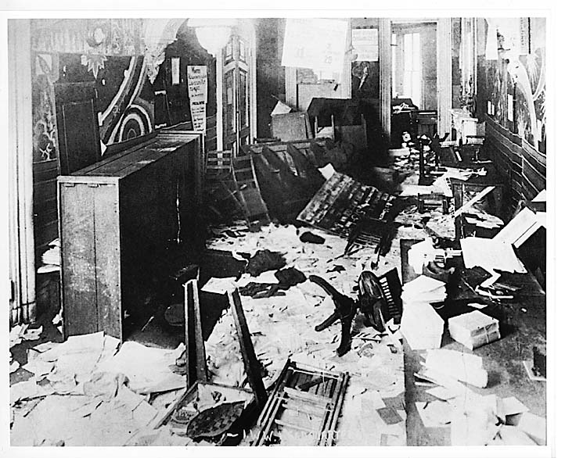

Bartolomeo Vanzetti’s Speech to the Jury
That I am not only innocent of these two crimes, but in all my life I have never stole and I have never killed and I have never spilled blood. That is what I want to say. And it is not all. Not only am I innocent of these two crimes, not only in all my life I have never stole, never killed, never spilled blood, but I have struggled all my life, since I began to reason, to eliminate crime from the earth.
Everybody that knows these two arms knows very well that I did not need to go in between the street and kill a man to take the money. I can live with my two arms and live well. But besides that, I can live even without work with my arm for other people. I have had plenty of chance to live inde- pendently and to live what the world conceives to be a higher life than not to gain our bread with the sweat of our brow. . . .
Well, I want to reach a little point farther, and it is this—that not only have I not been trying to steal in Bridgewater, not only have I not been in Braintree to steal and kill and have never steal or kill or spilt blood in all my life, not only have I struggled hard against crimes, but I have refused myself the commodity of glory of life, the pride of life of a good position because in my consideration it is not right to exploit man. . . .
Now, I should say that I am not only innocent of all these things, not only have I never committed a real crime in my life—though some sins, but not crimes—not only have I struggled all my life to eliminate crimes that the official law and the offi- cial moral condemns, but also the crime that the official moral and the official law sanctions and sanctifies,—the exploitation and the oppression of the man by the man, and if there is a reason why I am here as a guilty man, if there is a reason why you in a few minutes can doom me, it is this reason and none else.
I beg your pardon. There is the more good man I ever cast my eyes upon since I lived, a man that will last and will grow always more near and more dear to the people, as far as into the heart of the people, so long as admiration for goodness and for sacrifice will last. I mean Eugene Debs. . . . He know, and not only he but every man of under- standing in the world, not only in this country but also in the other countries, men that we have pro- vided a certain amount of a record of the times, they all stick with us, the flower of mankind of Europe, the better writers, the greatest thinkers, of Europe, have pleaded in our favor. The people of foreign nations have pleaded in our favor.
Is it possible that only a few on the jury, only two or three men, who would condemn their moth- er for worldly honor and for earthly fortune; is it possible that they are right against what the world, the whole world has say it is wrong and that I know that it is wrong? If there is one that I should know it, if it is right or if it is wrong, it is I and this man. You see it is seven years that we are in jail. What we have suffered during those years no human tongue can say, and yet you see me before you, not trembling, you see me looking you in your eyes straight, not blushing, not changing color, not ashamed or in fear. . . .
We have proved that there could not have been another Judge on the face of the earth more preju- diced and more cruel than you have been against us. We have proved that. Still they refuse the new trial. We know, and you know in your heart, that you have been against us from the very beginning, before you see us. Before you see us you already know that we were radicals, that we were under- dogs, that we were the enemy of the institution that you can believe in good faith in their goodness—I don’t want to condemn that—and that it was easy on the time of the first trial to get a verdict of guiltiness.
We know that you have spoke yourself and have spoke your hostility against us, and your despise- ment against us with friends of yours on the train, at the University Club, of Boston, on the Golf Club of Worcester, Massachusetts. I am sure that if the people who know all what you say against us would have the civil courage to take the stand, maybe your Honor—I am sorry to say this because you are an old man, and I have an old father—but maybe you would be beside us in good justice at this time.
When you sentenced me at the Plymouth trial you say, to the best part of my memory, of my good faith, that crimes were in accordance with my principle,—something of that sort—and you take off one charge, if I remember it exactly, from the jury. The jury was so violent against me that they found me guilty of both charges, because there were only two. . . .
We were tried during a time that has now passed into history. I mean by that, a time when there was hysteria of resentment and hate against the people of our principles, against the foreigner, against slackers, and it seems to me—rather, I am positive, that both you and Mr. Katzmann has done all what it were in your power in order to work out, in order to agitate still more the passion of the juror, the prejudice of the juror, against us. . . .
Well, I have already say that I not only am not guilty of these crimes, but I never commit a crime in my life,—I have never steal and I have never kill and I have never spilt blood, and I have fought against the crime, and I have fought and I have sac- rificed myself even to eliminate the crimes that the law and the church legitimate and sanctify.
This is what I say: I would not wish to a dog or to a snake, to the most low and misfortunate creature on the earth—I would not wish to any of them what I have had to suffer for things that I am not guilty of. But my conviction is that I have suffered for things that I am guilty of. I am suffering because I am a radical and indeed I am a radical; I have suffered because I was an Italian, and indeed I am an Italian; I have suffered more for my family and for my beloved than for myself; but I am so convinced to be right that if you could execute me two times, and if I could be reborn two other times, I would live again to do what I have done already. I have finished. Thank you.
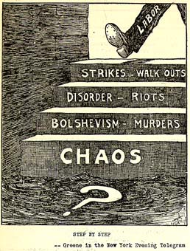

Teapot Dome Scandal

Even though it lasted only from 1921 to 1923, Harding's administration became the most scandal-ridden to date, thanks to several of his old political pals. Attorney General Harry Daugherty was accused of profiting from the sale of government alcohol supplies during Prohibition, as well as selling pardons. Harding's head of the Veterans Bureau, Charles Forbes, was sentenced to two years in prison for bribery and corruption. Other scandals involved appointees in the Shipping Bureau and Alien Property Custodians office. And, 85 years ago this week, Harding's Secretary of the Interior, Albert B. Fall, announced his resignation in the midst of an unfolding scandal that would become known as Teapot Dome.
American oil companies had long coveted these rich oil reserves, which included Elk Hills in California and Teapot Dome, near Casper, Wyoming, so named for a teapot-shaped boulder nearby. Without opening the process for competitive bidding, Fall arranged leases with two multimillionaire oil men, Harry Sinclair and Edward Doheny.
While outraging many, including conservationists, competing oil companies, and Navy officers, the leases appeared legal. Nonetheless, executives of several oil companies complained to Congress. In April 1922, Sen. Robert M. La Follette, Sr., a Progressive from Wisconsin, arranged for a Senate committee to look into the contracts.
When Fall first took the job as Interior Secretary, his personal financial situation was precarious: although he owned a dilapidated New Mexico ranch, he owed many debts as well as taxes going back to 1912. After the oil leases were signed, he abruptly paid off all his obligations. He also bought additional parcels of land for his ranch costing more than $120,000. His sudden reversal of fortune, attained while drawing a government salary of $12,000, soon aroused suspicion. Senate investigators, including Thomas J. Walsh of Montana, took a hard look at his finances. Fall resigned in early 1923 and accepted a job from Harry Sinclair. President Harding seemed unconcerned about the allegations against Fall; he even considered him for a post on the U.S. Supreme Court. The full extent of Falls corruption would come to light only after Harding's death in August 1923.
Investigators discovered that Sinclair and Doheny had bribed Fall with cash and large no-interest personal loans totaling approximately $404,000, or nearly $5 million in today's dollars. After the U.S. Supreme Court ruled in 1927 that the leases had been illegally obtained, they were canceled and control of the reserves reverted to the Navy. While Sinclair and Doheny escaped conviction on criminal charges arising from the Teapot Dome Scandal, the former served six months in prison for contempt of court. At one point, Doheny approached the director Cecil B. DeMille about making a movie presenting Doheny's side of the story. DeMille liked the idea, but the film was never made.
In 1929, Fall earned notoriety as the first former Cabinet officer ever convicted of a felony committed while in office. He was fined $100,000, which he never paid, and served just over nine months of a one-year prison sentence. "My version of the matter is simply that I was not guilty," he told the parole board. He died in 1944 at the age of 83, never have admitted his guilt. Until Watergate, Teapot Dome was the most infamous scandal involving a presidential administration.

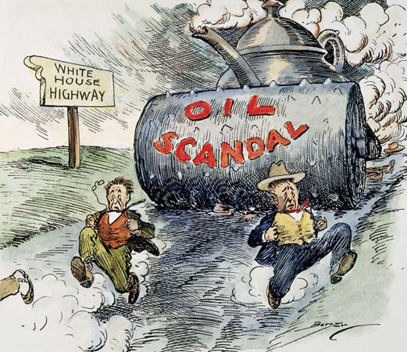

The shift in Americans' attitudes caused a similar shift in political power. By the end of the 1910s, Democratic President Woodrow Wilson had lost party support in a Congress which had become strongly Republican. The situation made it impossible for Wilson's post-World War I policies to be enacted. As the 1920s unfolded, Washington D.C. became a Republican stronghold. Republican presidential candidate Warren G. Harding won a landslide victory in 1920. Upon Harding's sudden death in 1923, Vice President Calvin Coolidge assumed the presidency. His election to a full term as president in 1924 assured the continuance of Republican Party policy. When Coolidge stepped aside in 1928, he paved the way for fellow Republican Herbert Hoover to take over the presidency. Throughout the decade, the Republicans held majorities in both houses of Congress.
The Republicans established a pro business approach that lasted throughout the decade. Government intervention in business matters was minimized. The federal government cut back on spending and allowed generous tax cuts. In general, the policies pleased the public. One exception was the agricultural community, whose members suffered substantially from lack of federal support.
With close ties between big business and government, scandals and corruption marred the 1920s. President Harding's attorney general Harry Daugherty left office over allegations of corruption, and then the director of the Veterans' Bureau stepped down over charges of fraud. The decade's most sensational scandal was the Teapot Dome affair, in which Albert Fall, Harding's secretary of the interior, took bribes in exchange for awards of oil leases. In 1923, he and Secretary of the Navy Edwin Denby resigned in disgrace over this matter.

The Drunkard and His Family children’s book
"Oh! oh!" sobbed the child with a smothered moan, which was far more pitiful than a loud cry. "Oh, my mother, my mother, will she ever kiss her little girl again?"
"Hush, hush, dear little sister, do not cry so; it almost breaks my heart to hear you," said Marcia, choking down her own sobs with a great effort.
Very hard indeed are the days following the death of Marcia and Ellen's mother. Daily they pray and ask the Lord to take care of them and to save their poor drinking father, whom they love dearly. The responsibility of finding food for them rests on Marcie, the older of the two girls.
Marcia entered the store, approached the counter and said in a trembling voice, "Please, Mr Greene, let me have a little flour or meal to make a cake for breakfast."
"I suppose you have the money to pay for it." said the man, looking sharply at her.
"But I have no money." said Marcia, while tears slowly gathered in her large, gray eyes.
"Well, ask your father for some. Tell him I saw him taking a walk last night by moonlight, and I would advise him, for decency's sake, to stop drinking and take care of his children."
Poor little Marcia's heart gave a great bound at these cruel words, and she turned away in an agony of tears.
We know the Lord's eye is upon the righteous, and His ear is open unto their cry. A blessing awaits your family as you share these experiences and others with "The Drunkard's Children." A true story that will be enjoyed by all ages.

Rise of Al Capone and Bootlegging
Through the criminal experience gained and the political connections established in gambling and prostitution rackets in the early 1900s, gangsters had become well prepared for the exploitation of Prohibition, which was ratified as the 18th Constitutional Amendment in 1919. Illegalizing the production, distribution, and consumption of alcoholic beverages - all of which were corollaries to the amendment - did not curb the desire of Chicagoans for liquor or beer. This great demand for and simultaneous illegalization of alcohol opened up a new illegal market for the gangster to develop and monopolize. As Al Capone put it, "All I do is to supply a public demand … somebody had to throw some liquor on that thirst. Why not me?" (Sullivan, 111).
This thirst repeatedly seen in the literature pertaining to Chicago's early 1900s (Prohibition - Literature Analysis).
Chicago's change for the worse - or to the worst - was exactly coincidental with the beginning of prohibition" (Sullivan, 182). This was mostly due to Al Capone's arrival to Chicago in 1920, when he inherited the leadership of Torrio's gang. It is important to note that this is the same year that Prohibition became enforced, although ratified in 1919. Capone had a brilliant criminal mind, and he focused it on organizing an international bootlegging (on this page, meaning specifically the illegal production, distribution, and sale of alcohol) ring . He coordinated the importation of alcohol from different locations, including other states and even Canada, as well as the operation of hundreds of breweries and distilleries, many of which resided in Chicago. Capone also devised a system to distribute his alcohol, which involved delivery truck drivers, salespeople, speakeasies (equivalent to a bar), and of course heavily-armed bodyguards to protect these investments.

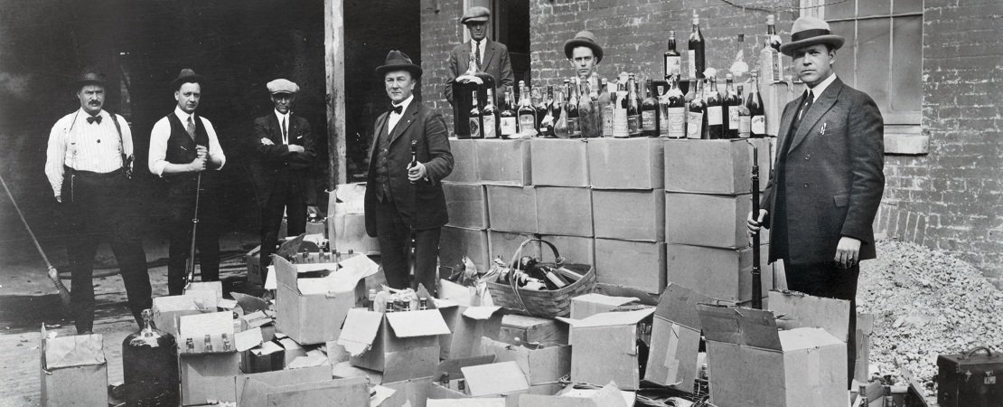

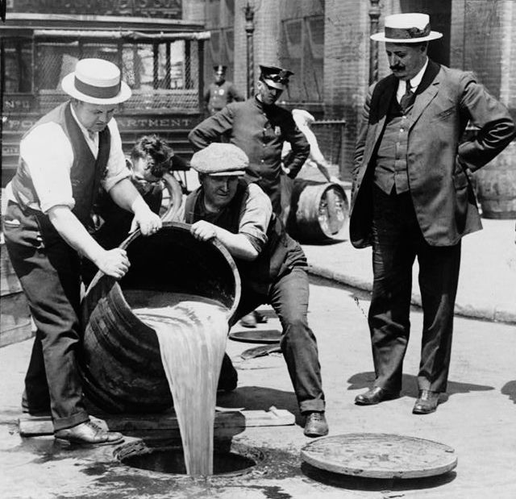

Scopes Trial Summary
It made for great oratory between eminent rivals, and it put the debate over teaching evolution on front pages across the country. But one thing the Scopes “monkey” trial of 1925 did not do was settle the contentious issue of evolution in schools, which continues to incite strong passions and court actions to this day.
Narrowly, the trial was about challenging a newly passed Tennessee state law against the teaching of evolution and any other theory denying the biblical accounts of the creation of man. Broadly, the case reflected a collision of tradition views and values with modern ones: it was a time of evangelism and figures such as Aimee Semple McPherson and Billy Sunday against forces, including jazz, sexual permissiveness, and race Hollywood movies, which they thought were undermining the authority of the bible and Christian morals of society.
John Scopes, the 24-year-old defendant, taught in a public high school in Dayton Tennessee, and included evolution in his curriculum. He agreed to be the focus of a test case attacking the new law, and was arrested for teaching evolution and tried with the American Civil Liberties Union backing his defense. His lawyer was the legendary Clarence Darrow, who, besides being a renowned defense attorney for labor and radical figures, was an avowed agnostic in religious matters.
The state’s attorney was William Jennings Bryan, a pacifist, and former candidate for U.S. president who agreed to take the case because he believed that evolution theory led to dangerous social movements. And he believed the bible should be interpreted literally.
The weather was stifling how and the rhetoric equally heated in this “trial of the century” attended by hundreds of reports and others who crowded into the Rhea County Court House in July 1925.Rather than the validity of the law under with Scopes was being charged, the authority of the Bible versus the soundness of Darwin’s theory became the focus of the arguments.
“Millions of guesses strung together” is how Bryan characterized evolutionary theory, adding that the theory made man “indistinguishable among the mammals”. Darrow, in his attacks, tried to poke holes in the Genesis story according to modern thinking, calling them “fool ideas that no intelligent Christian on earth believes”
The jury found Scopes guilty of violating the law and fined him 100 dollars. Bryant and the anti-evolutionaries claimed victory, and the Tennessee law would stand for another 42 years. But Clarence Darrow and the ACL had succeeded in publicizing scientific evidence for evolution, and the press reported that though Bryan had won the case, he had lost the argument. The verdict did have a chilling effect on teaching evolution in the classroom however, and not until the 1960s did it reappear in school books.

"You have given considerable study to the Bible, haven't you, Mr. Bryan?"
"Yes I have, I have studied the Bible for about fifty years."
"Do you claim that everything in the Bible should be literally interpreted?"
"I believe everything in the Bible should be accepted as it is given there ..."
"Do you believe Joshua made the sun stand still?"
"I believe what the Bible says."
"I suppose you mean that the earth stood still?"
"I don't know. I am talking about the Bible now. I accept the Bible absolutely."
More questions show that Bryan barely understands the workings of the solar system, then Darrow asks:
(Darrow) You believe the story of the flood to be a literal interpretation?
(Bryan) Yes sir.
(Darrow) When was that flood?
(Bryan) I would not attempt to fix the day.
(Darrow) But what do you think the Bible itself says? Don't you know how it was arrived at?
(Bryan) I never made a calculation.
(Darrow) What do you think?
(Bryan) I do not think about things I don't think about.
(Darrow) Do you think about the things you do think about?
(Bryan) Well sometimes.
Now, the crowd in the courtyard was laughing at Bryan instead of Darrow.
(Darrow) How long ago was the flood, Mr. Bryan?
(Bryan) Two-thousand three hundred and forty-eight years B.C.
(Darrow) You believe that all the living things that were not contained in the ark were destroyed?
(Bryan) I think the fish may have lived.
(Darrow) Don't you know there are any number of civilizations that are traced back to more than five thousand years?
(Bryan) I am not satisfied with any evidence I have seen.
(Darrow) You believe that every civilization on the earth and every living thing, except possibly the fishes, were wiped out by the flood?
(Bryan) At that time.
(Darrow) You have never had any interest in the age of the various races and peoples and civilizations and animals that exist upon the earth today?
(Bryan) I have never felt a great deal of interest in the effort that has been made to dispute the Bible by the speculations of men or the investigations of men.
(Darrow) And you never have investigated how long man has been on the earth?
(Bryan) I have never found it necessary.
(Darrow) Don't you know that the ancient civilizations of China are six thousand or seven thousand years old, at the very least?
(Bryan) No, but they would not run back beyond the creation, according to the Bible, six thousand years.
(Darrow) You don't know how old they are; is that right?
(Bryan) I don't know how old they are, but probably you do. I think you would give preference to anybody who opposed the Bible.
More questions show Bryan's lack of knowledge of world culture, history and people.
(Darrow) You have never in all your life made any attempt to find out about the other peoples of the earth - how old their civilizations are, how long they have existed on the earth - have you?
(Bryan) No sir, I have been so well satisfied with the Christian religion that I have spent no time trying to find arguments against it. I have all the information I want to live by and to die by.
(Darrow) Do you think the earth was made in six days?"
(Bryan) Not six days of 24 hours.
(Darrow) Did you ever discover where Cain got his wife?
(Bryan) No sir; I leave the agnostics to hunt for her.
(Darrow) Do you think the sun was made on the fourth day?
(Bryan) Yes.
(Darrow) And they had evening and morning without the sun?
(Bryan) I am simply saying it is a period.
(Darrow) The creation might have been going on for a very long time?
(Bryan) It might have continued for millions of years.
(Darrow) Yes, All right.

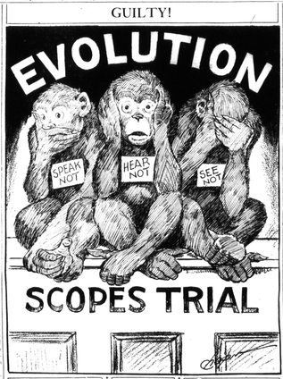

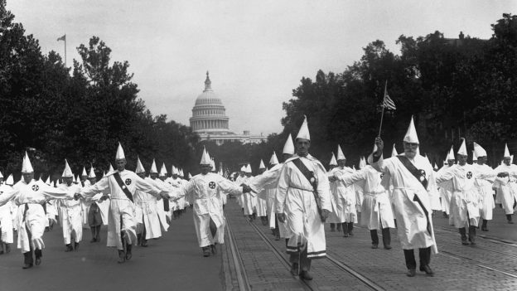

Rise of the Klan
Although the KKK had reemerged in the South in 1915, it wasn’t until after the end of World War I that the organization experienced a national resurgence. Membership in the KKK skyrocketed from a few thousand to over 100,000 in a mere ten months.22start superscript, 2, end superscript Local chapters of the KKK sprang up all over the country, and by the 1920s, it had become a truly national organization, with a formidable presence not just in the South, but in New England, the Midwest, and all across the northern United States.33start superscript, 3, end superscript
The members of the Ku Klux Klan were mostly white Protestant middle-class men, and they framed their crusade in moral and religious terms.44start superscript, 4, end superscript They saw themselves as vigilantes restoring justice, and they used intimidation, threats of violence, and actual violence to prevent African Americans, immigrants, Catholics, Jews, liberals, and progressives from attaining wealth, social status, and political power.
KKK members wore elaborate costumes with distinctive white hoods to mask their identities, and held nocturnal rallies to plot acts of terror and foment hatred against people deemed not “truly” American—basically, anyone who was not white and Protestant. The activities of Klansmen ranged from issuing threats and burning crosses to outright violence and atrocities such as tarring and feathering, beating, lynching, and assassination.
The revival of the KKK in the early twentieth century reflected a society struggling with the effects of industrialization, urbanization, and immigration. Klan chapters in major urban areas expanded as many white Americans became bitter and resentful about immigration from Asia and Eastern Europe. Klansmen complained that these immigrants were taking jobs away from whites and diluting the imagined “racial purity” of American society. Given that the country had been populated by immigrants from the beginning, such ideas of racial purity were complete myths.

The Birth of Nation
The Birth of a Nation is three hours of racist propaganda — starting with the Civil War and ending with the Ku Klux Klan riding in to save the South from black rule during the Reconstruction era.
"[Griffith] portrayed the emancipated slaves as heathens, as unworthy of being free, as uncivilized, as primarily concerned with passing laws so they could marry white women and prey on them," Dick Lehr, author of The Birth of a Nation: How a Legendary Filmmaker and a Crusading Editor Reignited America's Civil War, tells NPR's Arun Rath.

the film was the Avatar or Star Wars of 1915: It was a runaway hit.
After the first screening in Los Angeles, the film got a big thumbs-up. "The critics were raving. People were on their feet cheering at the climax of the film, when the Klan is seen as a healing force — restoring order to the chaos of the South during Reconstruction," Lehr says. "They were in awe of seeing for the first time a feature film of this length. There's one critic [who] said, 'The worst thing about The Birth of a Nation is how good it is.' "

