Andrew Jackson's Second Annual Message regarding Indian Removal
It gives me pleasure to announce to Congress that the benevolent policy of the Government, steadily pursued for nearly thirty years, in relation to the removal of the Indians beyond the white settlements is approaching to a happy consummation. Two important tribes have accepted the provision made for their removal at the last session of Congress, and it is believed that their example will induce the remaining tribes also to seek the same obvious advantages.
The consequences of a speedy removal will be important to the United States, to individual States, and to the Indians themselves. The pecuniary advantages which it promises to the Government are the least of its recommendations. It puts an end to all possible danger of collision between the authorities of the General and State Governments on account of the Indians. It will place a dense and civilized population in large tracts of country now occupied by a few savage hunters. By opening the whole territory between Tennessee on the north and Louisiana on the south to the settlement of the whites it will incalculably strengthen the southwestern frontier and render the adjacent States strong enough to repel future invasions without remote aid. It will relieve the whole State of Mississippi and the western part of Alabama of Indian occupancy, and enable those States to advance rapidly in population, wealth, and power. It will separate the Indians from immediate contact with settlements of whites; free them from the power of the States; enable them to pursue happiness in their own way and under their own rude institutions; will retard the progress of decay, which is lessening their numbers, and perhaps cause them gradually, under the protection of the Government and through the influence of good counsels, to cast off their savage habits and become an interesting, civilized, and Christian community.
What good man would prefer a country covered with forests and ranged by a few thousand savages to our extensive Republic, studded with cities, towns, and prosperous farms embellished with all the improvements which art can devise or industry execute, occupied by more than 12,000,000 happy people, and filled with all the blessings of liberty, civilization and religion?
The present policy of the Government is but a continuation of the same progressive change by a milder process. The tribes which occupied the countries now constituting the Eastern States were annihilated or have melted away to make room for the whites. The waves of population and civilization are rolling to the westward, and we now propose to acquire the countries occupied by the red men of the South and West by a fair exchange, and, at the expense of the United States, to send them to land where their existence may be prolonged and perhaps made perpetual. Doubtless it will be painful to leave the graves of their fathers; but what do they more than our ancestors did or than our children are now doing? To better their condition in an unknown land our forefathers left all that was dear in earthly objects. Our children by thousands yearly leave the land of their birth to seek new homes in distant regions. Does Humanity weep at these painful separations from everything, animate and inanimate, with which the young heart has become entwined? Far from it. It is rather a source of joy that our country affords scope where our young population may range unconstrained in body or in mind, developing the power and facilities of man in their highest perfection. These remove hundreds and almost thousands of miles at their own expense, purchase the lands they occupy, and support themselves at their new homes from the moment of their arrival. Can it be cruel in this Government when, by events which it can not control, the Indian is made discontented in his ancient home to purchase his lands, to give him a new and extensive territory, to pay the expense of his removal, and support him a year in his new abode? How many thousands of our own people would gladly embrace the opportunity of removing to the West on such conditions! If the offers made to the Indians were extended to them, they would be hailed with gratitude and joy.
And is it supposed that the wandering savage has a stronger attachment to his home than the settled, civilized Christian? Is it more afflicting to him to leave the graves of his fathers than it is to our brothers and children? Rightly considered, the policy of the General Government toward the red man is not only liberal, but generous. He is unwilling to submit to the laws of the States and mingle with their population. To save him from this alternative, or perhaps utter annihilation, the General Government kindly offers him a new home, and proposes to pay the whole expense of his removal and settlement.

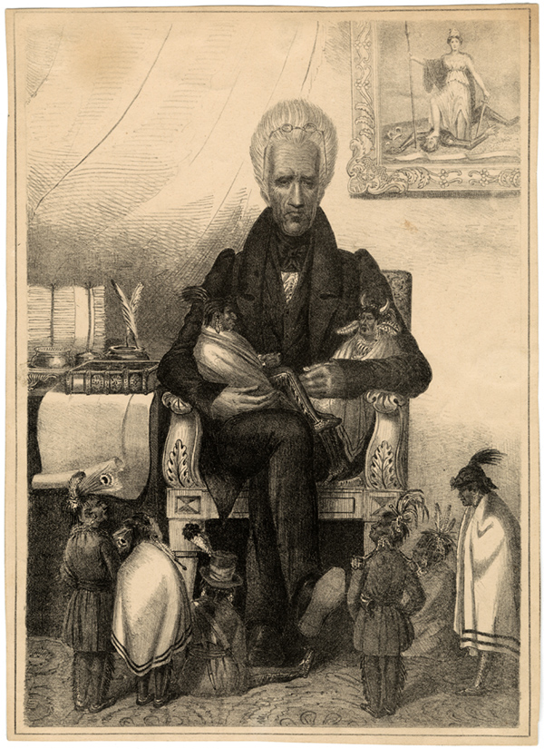

Cherokee’s Statement to Supreme Court Regarding Removal and Land
In addition to that first of all rights, the right of inheritance and peaceable possession, we have the faith and pledge of the United States, repeated over and over again in treaties made at various times. By these treaties our rights as a separate people are distinctly acknowledged, and guaranties given that they shall be secured and protected. So we have always understood the treaties. The conduct of the Government towards us, from its organization until very lately, the talks given to our beloved men by the Presidents of the United States, and the speeches of the Agents and Commissioners, all concur to show that we are not mistaken in our interpretation. Some of our beloved men who signed the treaties are still living, and their testimony tends to the same conclusion. We have always supposed that this understanding of the treaties was in accordance with the views of the Government; nor have we ever imagined that anybody would interpret them otherwise. In what light shall we view the conduct of the United States and Georgia, in their intercourse with us in urging us to enter into treaties, and cede lands? If we were but tenants at will, why was it necessary that our consent must first be obtained before these Governments could take lawful possession of our lands? The answer is obvious. These governments perfectly understood our rights—our right to the country, and our right to self government. Our understanding of the treaties is further supported by the intercourse law of the United States, which prohibits all encroachments upon our territory. The undersigned memorialists humbly represent, that if their interpretation of the treaties has been different from that of the Government then they have ever been deceived as to how the Government regarded them, and what she has asked and promised. Moreover, they have uniformly misunderstood their own acts.

Excerpt from Cherokee Nation about the Trail of Tears

Number of Native Americans forcibility removed: 16,000
Number of Native Americans killed: 4,000

Under orders from President Jackson the U.S. Army began enforcement of the Removal Act. The Cherokee were rounded up in the summer of 1838 and loaded onto boats that traveled the Tennessee, Ohio, Mississippi and Arkansas Rivers into Indian Territory. Many were held in prison camps awaiting their fate.
An estimated 4,000 died from hunger, exposure and disease. The journey became a cultural memory as the "trail where they cried" for the Cherokees and other removed tribes. Today it is widely remembered by the general public as the "Trail of Tears".

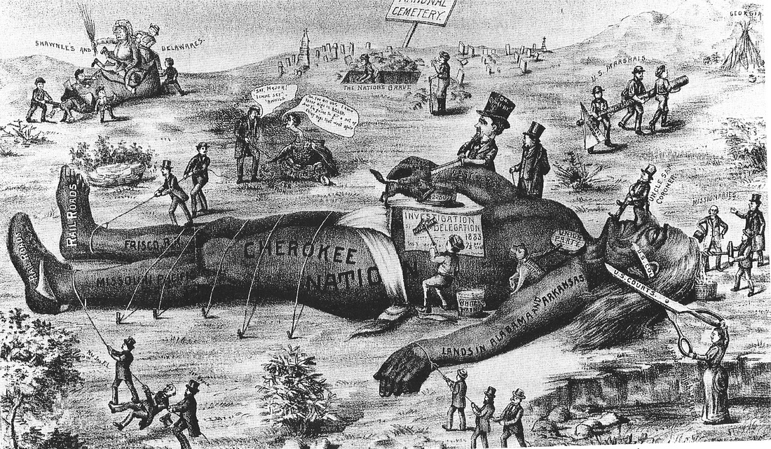

John C. Calhoun and South Carolina and Nullification
The Senate and House of Representatives of South Carolina, now met and sitting in General Assembly, through the Hon. William Smith and the Hon. Robert Y. Hayne, their Representatives in the Senate of the United States, do, in the name and on behalf of the good people of the said Commonwealth, solemnly protest against the system of protecting duties, lately adopted by the Federal Government, for the following reasons:
1st. Because the good people of this commonwealth believe, that the powers of Congress were delegated to it, in trust for the accomplishment of certain specified objects which limit and control them, and that every exercise of them, for any other purposes, is a violation of the Constitution as unwarrantable as the undisguised assumption of substantive, independent powers not granted, or expressly withheld.
3d. Because they believe that the Tariff Law passed by Congress at the last session, and all other acts of which the principal object is the protection of manufactures, or any other branch of domestic industry, if they considered as the exercise of a supposed power in Congress to tax the people at its own good will and pleasure, and to apply the money raised to objects not specified in the Constitution, is a violation of these fundamental principles, a breach of a well-defined trust, and a perversion of the humble powers vested in the Federal Government for federal purposes only.
8th. Finally, because South Carolina, from her climate, situation, and peculiar institutions, is, and must ever continue to be, wholly dependent upon agriculture and commerce, not only for her prosperity, but for her very existence as a State—because the valuable products of her soil—the blessings by which Divine Providence seems to have designed to compensate for the great disadvantages under which she suffers in other respects—are among the very few that can be cultivated with any profit by slave labor—and if, by the loss of
her foreign commerce, these products should be confined to an inadequate market, the fate of this fertile State would be poverty and utter desolation; her citizens, in despair, would emigrate to more fortunate regions, and the whole frame and constitution of her civil polity, be impaired and deranged, if not dissolved entirely.
Deeply impressed with these considerations, the representatives of the good people of this commonwealth, anxiously desiring to live in peace with their fellow-citizens and to do all that in them lies to preserve and perpetuate the union of the State and the liberties of which it is the surest pledge—but feeling it to be their bounden duty to expose and resist all encroachments upon the true spirit of the Constitution, lest an apparent acquiescence in the system of protecting duties should be drawn into precedent—do, in the name of the commonwealth of South Carolina, claim enter upon the journals of the Senate, their protest against it as unconstitutional, oppressive, and unjust.

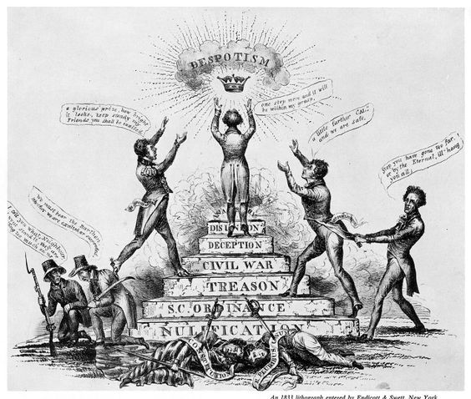

Jackson addressing Congress about South Carolina nullification

If these measures can not be defeated and overcome by the power conferred by the Constitution on the Federal Government, the Constitution must be considered as incompetent to its own defense, the supremacy of the laws is at an end, and the rights and liberties of the citizens can no longer receive protection from the Government of the Union. They not only abrogate the acts of Congress commonly called the tariff acts of 1828 and 1832, but they prostrate and sweep away at once and without exception every act and every part of every act imposing any amount whatever of duty on any foreign merchandise, and virtually every existing act which has ever been passed authorizing the collection of the revenue, including the act of 1816, and also the collection law of 1799, the constitutionality of which has never been questioned. It is not only those duties which are charged to have been imposed for the protection of manufactures that are thereby repealed, but all others, though laid for the purpose of revenue merely, and upon articles in no degree suspected of being objects of protection. The whole revenue system of the United States in South Carolina is obstructed and overthrown, and the Government is absolutely prohibited from collecting any part of the public revenue within the limits of that State. Henceforth, not only the citizens of South Carolina and of the United States, but the subjects of foreign states may import any description or quantity of merchandise into the ports of South Carolina without the payment of any duty whatsoever. That State is thus relieved from the payment of any part of the public burthens, and duties and imposts are not only rendered not uniform throughout the United States, but a direct and ruinous preference is given to the ports of that State over those of all the other States of the Union, in manifest violation of the positive provisions of the Constitution

The rich inheritance bequeathed by our fathers has devolved upon us the sacred obligation of preserving it by the same virtues which conducted them through the eventful scenes of the Revolution and ultimately crowned their struggle with the noblest model of civil institutions. They bequeathed to us a Government of laws and a Federal Union founded upon the great principle of popular representation. After a successful experiment of forty-four years, at a moment when the Government and the Union are the objects of the hopes of the friends of civil liberty throughout the world, and in the midst of public and individual prosperity unexampled in history, we are called to decide whether these laws possess any force and that Union the means of self-preservation. The decision of this question by an enlightened and patriotic people can not be doubtful. For myself, fellow-citizens, devoutly relying upon that kind Providence which has hitherto watched over our destinies, and actuated by a profound reverence for those institutions I have so much cause to love, and for the American people, whose partiality honored me with their highest trust, I have determined to spare no effort to discharge the duty which in this conjuncture is devolved upon me. That a similar spirit will actuate the representatives of the American people is not to be questioned; and I fervently pray that the Great Ruler of Nations may so guide your deliberations and our joint measures as that they may prove salutary examples not only to the present but to future times, and solemnly proclaim that the Constitution and the laws are supreme and the Union indissoluble.

Jackson discussing his veto of the National Bank

"A bank of the United States is in many respects convenient for the Government and
useful to the people. Entertaining this opinion, and deeply impressed with the belief that
some of the powers and privileges possessed by the existing bank are unauthorized by the
Constitution, subversive of the rights of the States, and dangerous to the liberties of the
people…."
"The present corporate body, denominated the president, directors, and company of the
Bank of the United States, will have existed at the time this act is intended to take effect
twenty years. It enjoys an exclusive privilege of banking under the authority of the
General Government, a monopoly of its favor and support, and, as a necessary
consequence, almost a monopoly of the foreign and domestic exchange. The powers,
privileges, and favors bestowed upon it in the original charter, by increasing the value of
the stock far above its par value, operated as a gratuity of many millions to the
stockholders.
Experience should teach us wisdom. Most of the difficulties our Government now
encounters and most of the dangers which impend over our Union have sprung from an
abandonment of the legitimate objects of Government by our national legislation, and the
adoption of such principles as are embodied in this act. Many of our rich men have not
been content with equal protection and equal benefits, but have besought us to make them
richer by act of Congress. By attempting to gratify their desires we have in the results of
our legislation arrayed section against section, interest against interest, and man against
man, in a fearful commotion which threatens to shake the foundations of our Union. If
we can not at once, in justice to interests vested under improvident legislation, make our
government what it ought to be, we can at least take a stand against all new grants of
monopolies and exclusive privileges, against any prostitution of our Government to the
advancement of the few at the expense of the many, and in favor of compromise and
gradual reform in our code of laws and system of political economy."

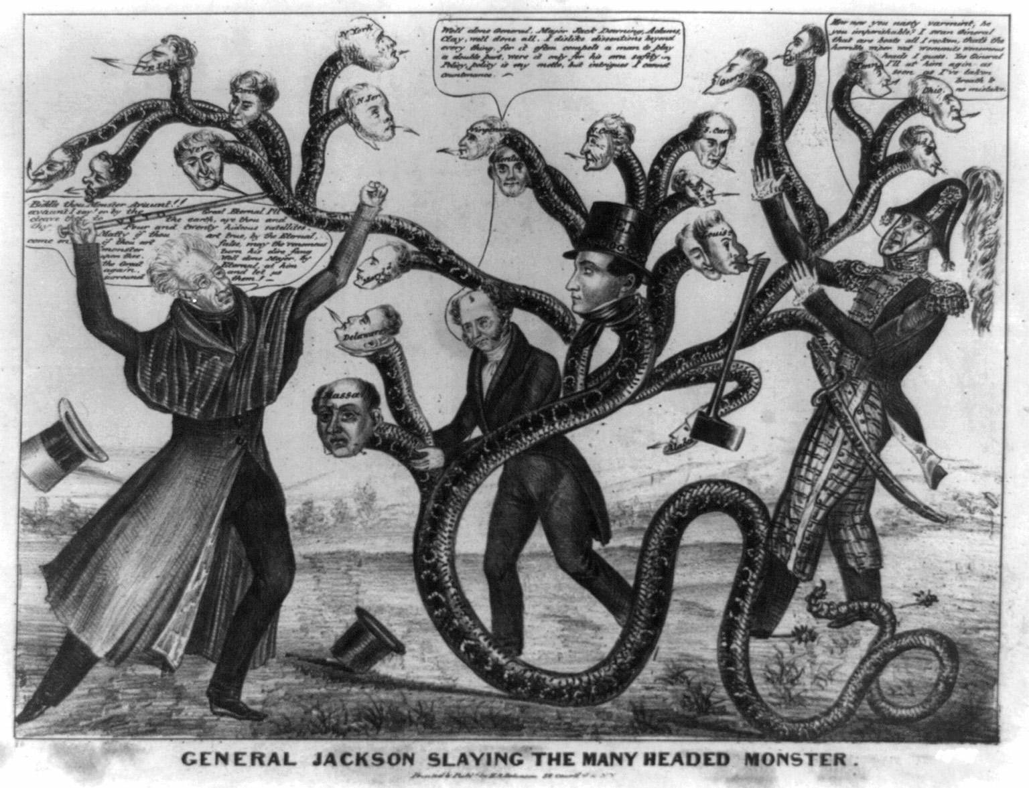

Henry Clay addressing Congress about Jackson’s veto of the National Bank
Mr. President, I protest against the right of any chief magistrate to come into either House of Congress, and scrutinize the motives of its members; to examine whether a measure has been passed with promptitude or repugnance; and to pronounce upon the willingness or unwillingness with which it has been adopted or rejected. It is an interference in concerns which partake of a domestic nature. The official and constitutional relations between the president and the two Houses of Congress subsist with them as organized bodies. His action is confined to their consummated proceedings, and does not extend to measures in their incipient stages, during their progress through the Houses, nor to the motives by which they are actuated. There are some parts of this message that ought to excite deep alarm; and that especially in which the president announces, that each public officer may interpret the Constitution as he pleases. His language is, "Each public officer, who takes an oath to support the Constitution, swears that he will support it as he understands it, and not as it is understood by others." * * * "The opinion of the judges has no more authority over Congress than the opinion of Congress has over the judges; and on that point the president is independent of both." Now, Mr. President, I conceive, with great deference, that the president has mistaken the purport of the oath to support the Constitution of the United States. No one swears to support it as he understands it, but to support it simply as it is in truth. All men are bound to obey the laws, of which the Constitution is the supreme; but must they obey them as they are, or as they understand them? If the obligation of obedience is limited and controlled by the measure of information; in other words, if the party is bound to obey the Constitution only as he understands it; what would be the consequence? The judge of an inferior court would disobey the mandate of a superior tribunal, because it was not in conformity to the Constitution, as he understands it; a custom-house officer would disobey a circular from the Treasury department, because contrary to the Constitution, as he understands it; an American minister would disregard an instruction from the president, communicated from the Department of State, because not agreeable to the Constitution, as he understands it; and a subordinate officer in the army or navy, would violate the orders of his superior, because they were not in accordance with the Constitution, as he understands it. We should have nothing settled, nothing stable, nothing fixed. There would be general disorder and confusion throughout every branch of administration, from the highest to the lowest officers -- universal nullification. For what is the doctrine of the president but that of South Carolina applied throughout the Union? The president independent both of Congress and the Supreme Court! only bound to execute the laws of the one and the decisions of the other, as far as they conform to the Constitution of the United States, as far as he understands it! Then it should be the duty of every president, on his installation into office, to carefully examine all the acts in the statute book, approved by his predecessors, and mark out those which he was resolved not to execute, and to which he meant to apply this new species of veto, because they were repugnant to the Constitution as he understands it. And, after the expiration of every term of the Supreme Court, he should send for the record of its decisions, and discriminate between those which he would, and those which he would not, execute, because they were or were not agreeable to the Constitution, as he understands it.
Mr. President, we are about to close one of the longest and most arduous sessions of Congress under the present Constitution; and when we return among our constituents, what account of the operations of their government shall we be bound to communicate? We shall be compelled to say, that the Supreme Court is paralyzed, and the missionaries retained in prison in contempt of its authority, and in defiance of numerous treaties and laws of the United States; that the executive, through the Secretary of Treasury, sent to Congress a tariff bill which would have destroyed numerous branches of our domestic industry, and to the final destruction of all; that the veto has been applied to the bank of the United States, our only reliance for a sound and uniform currency; that the Senate has been violently attacked for the exercise of a clear constitutional power; that the House of Representatives have been unnecessarily assailed; and that the president has promulgated a rule of action for those who have taken the oath to support the Constitution of the United States, that must, if there be practical conformity to it, introduce general nullification, and end in the absolute subversion of the government.

