30.2 The Renaissance Spreads Through Europe

As you have learned, the Renaissance began in Italy. From there it spread to France, Germany, Flanders (modern day Belgium), Holland, England, and Spain.
Renaissance ideas were spread through trade, travel, and education. Italy was the gateway to Europe for much of the trade from Asia, Africa, and the Greek speaking cities of the east. Traders moved through Italy to the rest of Europe, bringing a rich flow of ideas along with their goods.
Visitors to Italy also helped spread Renaissance ideas. People from all over Europe traveled to Italy to learn as well as to trade. Scholars went to study humanism. Artists studied Italian painting and sculpture to learn new styles and techniques.
When these travelers returned home, many of them founded art schools and universities. Artists taught others what they had learned in Italy. Scholars began to teach the new ideas of experimentation and logical thinking.
The spread of ideas was made even easier by the invention of the printing press. This machine presses inked type or plates onto paper to create many copies of a work. Gradually, knowledge of papermaking and examples of Chinese printing blocks reached Europe.
In about 1450, a German named Johannes Gutenberg dramatically improved on existing printing methods. He invented a printing press that used movable type-characters that could be rearranged and used over again on other printing jobs. Unlike the Chinese, Gutenberg cast his type in medal.
Before Gutenberg’s invention, most books were written and copied by hand. It would four or five months to copy a 200-page book. The new press could produce 300 pages in a single day. As a result, more books and short works called pamphlets could be made much more quickly and cheaply.
The number of printers in Europe soon increased rapidly. People used printed matter to spread new ideas, discoveries, and inventions. And since printed material was more widely available, more people learned to read.
As new ideas spread, people in more countries were swept up in the spirit of the Renaissance.

Michelangelo, Italian Sculptor and Painter

Michelangelo was born in a small village near Florence in 1475. He grew up to become one of the greatest painters and sculptors in history.
Historians say that Michelangelo had a difficult childhood. His mother died when he was six years old. His father was stern and demanding. Perhaps this troubled early life contributed to Michelangelo’s famously bad temper. Although he was very religious, he was known to use fierce words when he was angry. He was also intensely ambitious.
When Michelangelo was 12, he became an apprentice to a painter in Florence. At 15, he began studying under a sculptor who worked for the powerful Medici family. Michelangelo lived for a time in the Medici home. There he met many thinkers, artists, and writers.
Michelangelo was amazingly gifted in both sculpture and painting. His art combines ideas of beauty with emotional expressiveness. To other artists, Michelangelo’s talent seemed almost godlike.
Michelangelo’s sculptures show his amazing talent for bringing life to figures carved from giant blocks of marble. When he was just 24, he carved his famous Pieta. A pieta is a depiction of Mary, the mother of Jesus, mourning over her crucified son. Michelangelo’s Pieta shows Mary tenderly holding the body of Jesus on her lap.
Two other significant sculptures by Michelangelo are his David and Moses. As you learned, David is 17 feet tall. The statue combines great beauty with the intense look of a youth who is about to go into battle. Michelangelo’s Moses is also a strong, powerful figure. In the Bible, Moses receives the Ten Commandments from God. Meanwhile, his people, the Hebrews, are worshipping false gods. The expression of Michelangelo’s Moses is a mixture of compassion and anger.
Michelangelo is perhaps best known for painting the ceiling of the Sistine Chapel, the pope’s chapel in Rome. Michelangelo labored for almost four years on a high platform to complete this work. He covered the curved ceiling with brilliantly colored scenes from the Bible. The scenes contain over 300 figures and continue to awe visitors to Rome today.
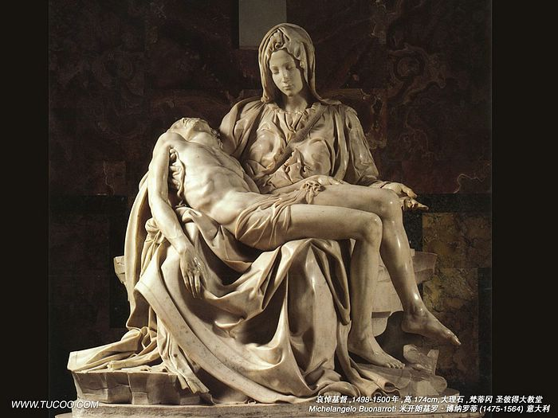
Titian, Italian Painter

Titian was born in a village in the Italian Alps around 1488. The exact date of his birth is uncertain. Early in life, Titian’s talent took him to the wealthy society of Venice. He became the cities greatest Renaissance painter.
As a boy, Titian was sent to Venice to train with famous painters. As a young man he worked with an artist named Giorgione, a master of fresco painting (a fresco painted on the wet plaster of a wall or ceiling. Titian also studied examples of art from Rome and Florence. In time, he outgrew the influence of his teachers and created his own style.
Titian was a persuasive man. According to legend, long after he was rich and famous, he persuaded patrons to support his art by claiming to be poor. But he was also said to be quite generous with his friends.
Titian’s early work was precise and detailed. Later he developed a freer style. He used blobs of paint to create vivid forms, colors, and textures. He was known for his inspired use of color and for loose. Lively brushwork that made his pictures appear to be alive. His work also shows a flair for expressing human personality.
Titian painted many classical myths and Bible stories. As a court painter, he created portraits of the rich and powerful. In 1516, he was named the official painter of Venice. Later, Holy Roman emperor Charles V made him court painter of Italy. Titian made many portraits of Charles V and other royalty.
Charles greatly admired Titian’s work. There is a story that the emperor once picked up a paintbrush that had fallen to the floor. Titian protested, “I am not worthy of such a servant”. The emperor replied, “Titian is worthy to be served by Caesar”, referring to the emperor of ancient Rome. Charles even made Titian a knight- a first time honor for a painter.
Titian is often described as a “painter’s painter” because of his influence on other artists’ use of color and brush strokes. Centuries later, many painters still try to copy his techniques.
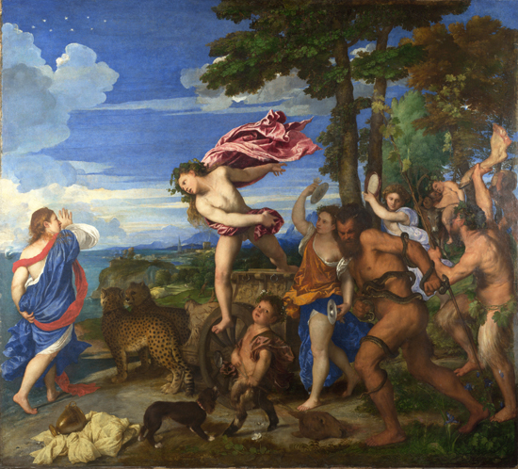

Albrecht Durer, German Artist

Albrecht Durer was born in the German city of Nuremberg in 1471. He earned fame for his paintings, drawings, prints, and writings on art.
As a boy, Durer, received a varied education. The son of a goldsmith, he learned his father’s trade. At 15, he began training with a well known painters and printmakers. He also studied math, Latin, and classic literature.
As a young man, Durer traveled through Germany, Italy, and the Netherlands. He became friends with many humanist writers, artists, and thinkers. He studied classical sculpture for years to learn ideal human proportions. He wanted to be able to show the parts of the human body correctly sized in relation to each other.
Durer’s self-portraits show him t be a fashionable, confident man. He had an intellectual approach to life and art. He asked himself “what is beauty?” his art was an attempt to answer that question.
In his painting, Durer blended the detailed style of Germany with the perspective and idealized beauty that he learned from Italian painting. He encouraged artists to study measurement and geometry as the keys to understanding Renaissance and classical art.
Durer was especially skilled at making engravings and woodcuts. These are prints made from an original that is specially prepared for painting. The original may be etched, or engraved, in metal, or it may be cut into a block of wood. Then it is inked to make copies. In Renaissance times, printers used engravings and woodcuts to illustrate books.
Much of Durer’s art shows religious figures. He also painted subjects from myths and did a series of self-portraits. Like other artists of his time, he did many portraits of royalty and wealthy patrons. He worked for years as a court artist for Holy Roman emperor Maximilian I.
Durer’s work is widely admired, particularly his beautiful engravings and woodcuts. These works set a new standard in printing because of their clarity, expressiveness, and fine detail. Durer also wrote influential books about human proportions in art. Many modern artists still read these writings.
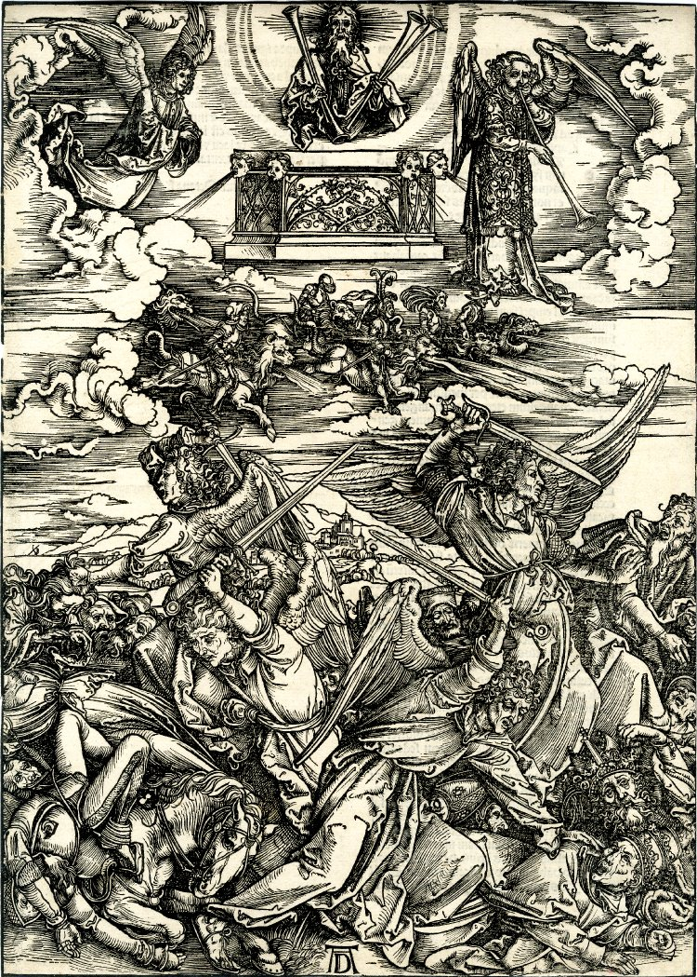

Nicolaus Copernicus, Polish Scientists

Nicolaus Copernicus was born in Torun Poland in 1473. He is often called the father of modern astronomy.
When Copernicus was ten years old, his father died. His uncle, a Catholic bishop, became his guardian. He made sure that Copernicus received a good education.
As a young man, Copernicus attended Poland’s University of Krakow. Then he went to Italy to study medicine and church law. In Italy he rented rooms at an astronomy teacher’s house. Soon he became fascinated by astronomy.
Copernicus’s scientific work would show that he was highly creative. He was also a free thinker, unafraid to question accepted beliefs.
Copernicus was skilled in mathematics and observation. He based his thinking on what he truly saw, rather than on what he thought he should see.
Like others of his day, Copernicus had been taught that the Earth was the center of the universe. According to this idea, the sun, stars, and planets traveled around earth.
As Copernicus studied the motion of the planets, he became dissatisfied with this explanation. He proposed a revolutionary idea. People, he said, had it backward. In reality, Earth and the other planets revolve around the sun. Earth rotates, or turns, on its axis. This turning is what makes the sun and other objects in the heavens seem to move across the sky.
In 1514, Copernicus printed a booklet that outlined his theory. Then he began years of work on a full-length book. He called it On the Revolutions of the Celestial Spheres. According to legend, he saw his book in print just a few hours before his death in 1543.
Copernicus dedicated his book to the pope. However, the idea of Earth traveling around the sun went against the church’s belief that God had placed humans at the center of the universe. In 1616, the church forbade people to read Copernicus’s book.
Despite the church’s disapproval, Copernicus’s theory had a major influence on a few key scientists. Eventually it was proved to be correct. Today the Copernican theory is part of the basis of modern astronomy.
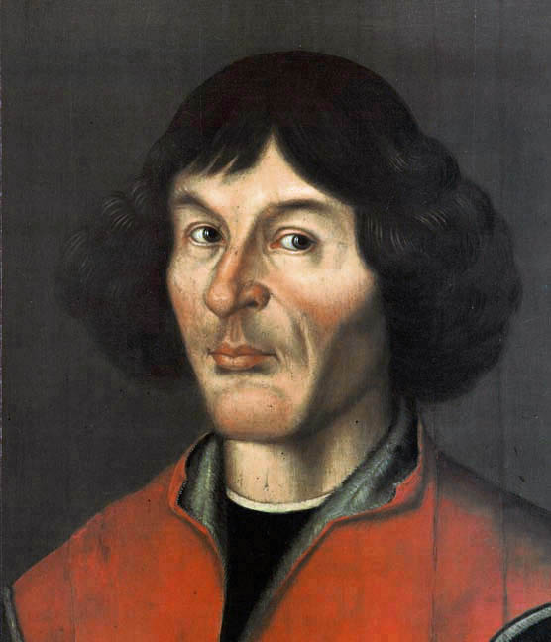
Andrea Vesalius, Belgian Scientist

Andreas Vesalius was born in Brussels in 1514, in what is now Belgium. He became an outstanding scientist. His work changed medicine and the study of anatomy.
Vesalius came from a family of doctors and pharmacists. He was always interested in living things, and especially in anatomy. As a young boy, he studied stray dogs and cats.
Vesalius attended universities in Belgium, France, and Italy. In 1537, he earned his medical degree, specializing in anatomy. Later he became a personal doctor for Italian and Spanish royalty. Vesalius was hardworking, curious, and confident. He was also said to be gloomy and distant times.
Vesalius was a talented observer and an independent thinker. He also had the artistic skill to draw his observations.
In Vesalius’s day, physicians’ understanding of human anatomy was based on the works of ancient Greek physician Galen. Vesalius studied Galen, by the soon broke with this tradition. Like Copernicus, he was determined to observe things for himself.
Vesalius began dissecting dead human bodied. His research showed that Galen’s work had relied on studies of animals. As a result, it had many errors when applied to humans.
Vesalius made many discoveries about the human body. For example, he showed that the human heart has four hollow areas, called chambers. His discoveries led him to write his own seven-volume textbook of anatomy.
Vesalius called his book On the Structure of the Human Body. It explained the construction of the body and how the body functions. The book contained prints by artists that were based on Vesalius’s drawings of the body.
Vesalius’s book was a major breakthrough. It changed what people knew about human anatomy and how they studied it. It also changed physician’s understanding of medicine. Today his book is seen as the world’s first modern medical textbook.
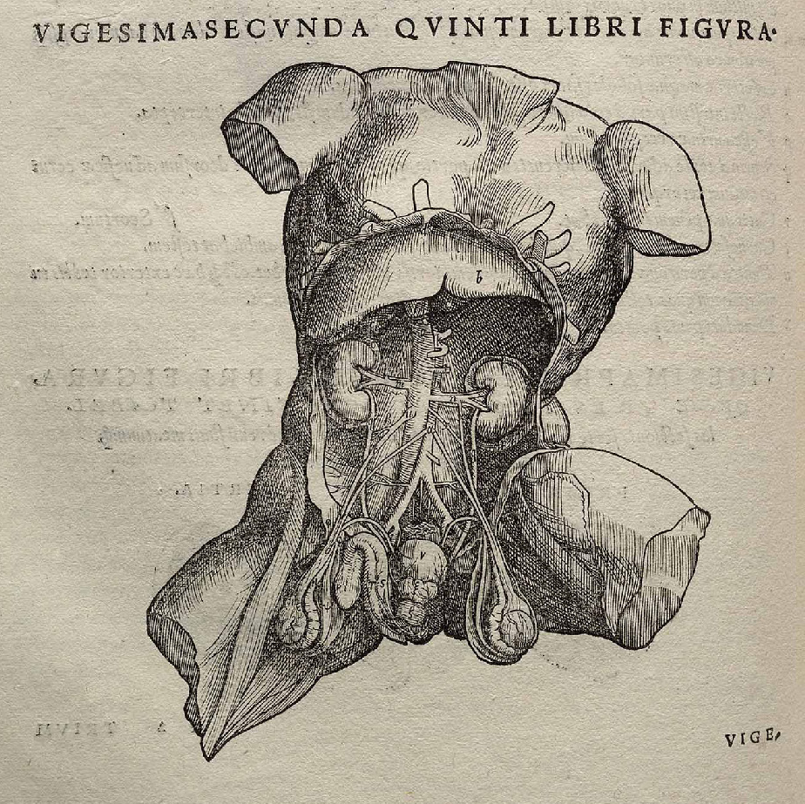

Isabella I, Queen of Spain

Queen Isabella was born in the Spanish kingdom of Castile in 1451. She is best remembered for helping to unify Spain and for sponsoring the voyages of Christopher Columbus.
Isabella was the daughter of the king of Castile. She was highly intelligent, strong willed, and a devoted Catholic. Girls at that time received little education, so Isabella’s schooling was limited. In adulthood, she educated herself by learning Latin. As queen, she supported scholarship and art, collected fine paintings and built schools.
When her father died, Isabella’s half brother, Henry, became king. At 13, Isabella was brought to Henry’s court. There she learned about court affairs.
Isabella was a forceful woman who could hold her own in court politics. Again Henry’s wishes, in 1469 she married Ferdinand of Aragon, prince of the other major kingdom in Spain at the time. When Henry died five years later, Isabella became queen of Castile. In 1479, Ferdinand inherited the throne of Aragon. The two monarchs now ruled jointly over a united Spain..
Isabella and Ferdinand actively encouraged exploration. Isabella gave her support to Christopher Columbus, an Italian who proposed to find a new sea route to Asia. In 1492, Columbus sailed across the Atlantic and stumbled upon the Americas. His discovery of the “New World” would lead to a Spanish empire and create great wealth for Spain.
Isabella and Ferdinand also sought to further unify Spain as a Catholic country. Jews who refused to convert to Catholicism were forced to leave the country. This harsh action cost Spain many of its most talented and productive citizens. For the Spanish Jews, it was a tragedy.
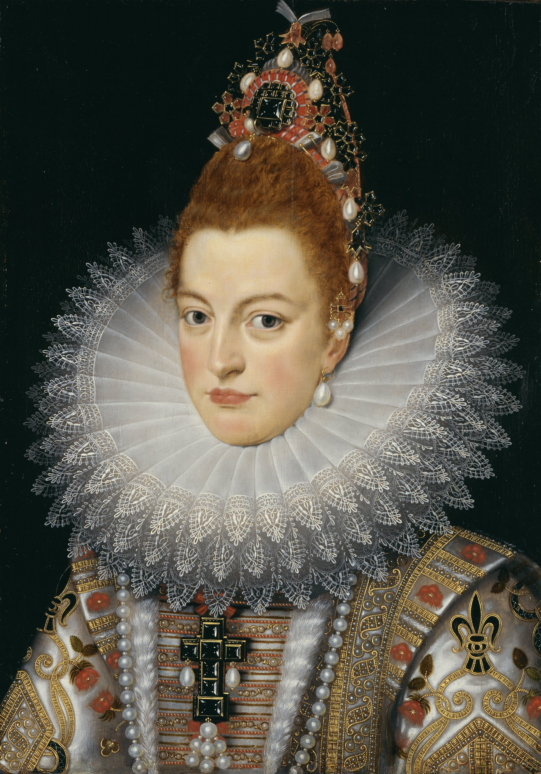

30.9 Elizabeth, Queen of England

Queen Elizabeth was one of England’s most popular and successful monarchs. Born in London in 1533, she was the daughter of King Henry VIII and his second wife, Anne Boleyn.
When Elizabeth was two years old, King Henry lost interest in her mother, Queen Anne. Claiming that Anne had been unfaithful to him, he had her beheaded.
Elizabeth was raised in a separate household, away from the royal court. An English scholar became her teacher and educated her as a possible future monarch. Elizabeth was a gifted student, she became highly educated and learned to speak Greek, Latin, French and Italian.
Elizabeth was a strong-minded ruler, but she was not stubborn. As queen she was willing to listen to good advice and was always devoted to England.
Elizabeth became queen at age 25 and reigned for 45 years, until her death. She never married, because she feared that a husband would take her power. She said she was married to the people of England.
Elizabeth was a conscientious and able ruler. She was strong and independent, but she was also flexible. She was willing to change unpopular policies. She showed political skill in balancing the interests of different people in her court. She inspired great love and loyalty from her subjects, who called her “good Queen Bess”.
Elizabeth’s long reign is often called England’s Golden Age. Culture thrived under her. She supported theater, fashion, literature, dance and education. Poets and playwrights composed some of the greatest works in the English language.
Elizabeth worked to strengthen England’s economy, and she encouraged trade and commerce. She authorized English trading companies in Africa, Asia, and the Americas. Her funding of sea exploration helped England gain a foothold in North America. In 1588, the English navy defeated the Spanish Armada, a mighty fleet that tried to attack England. This victory sparked a national celebration and further strengthened England’s sea power. By the time Elizabeth died, England was one of the strongest and richest countries in the world.

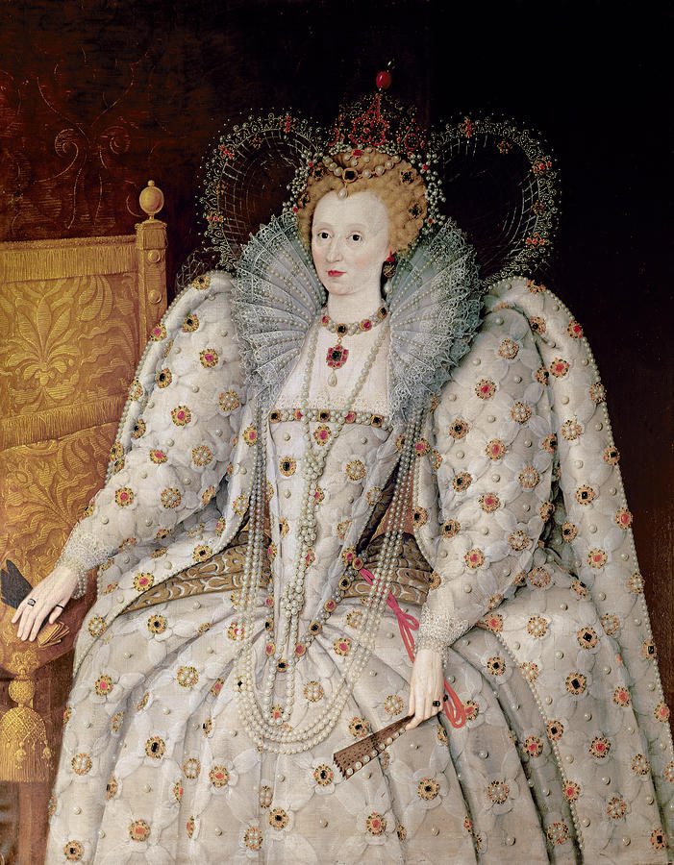
30.10 William Shakespeare, English Poet and Playwright

William Shakespeare was born in the English town of Stratford-on Avon in 1564. He was a major figure in the English Renaissance. He is often called the world’s greatest playwright and one of its finest poets.
Shakespeare’s father was a glove maker. As a boy, William studied Latin and classical literature in grammar school. He never went to a university. His plays, however, show a broad knowledge of many subjects from history and politics to music and art.
In his early 20s, Shakespeare became an actor with a theater company in London. He learned about drama by performing and writing plays for the company. Many of his plays were first presented at the Globe Theater.
Shakespeare had a reputation for being quiet and a bit mysterious. His writings show that he was curious and keenly observant. He thought deeply about life and its sufferings. Yet he also had a sense of humor and found much to laugh at in life.
Shakespeare was a skilled actor, but he was an even greater poet and playwright. He had an enormous talent for expressing thoughts and feelings in memorable ways. His plays show that he had a deep understanding of human behavior and emotions. Above all, he had the skill to present his understanding through vivid characters and exciting drama.
Shakespeare’s poetry is widely admired, especially the 14 line poems called sonnets. Many of his sonnets are beautiful love poems. He is best known, however, for his plays. He wrote both comedies and tragedies. Many of his 38 plays are still performed around the world. Among the most popular are Romeo and Juliet, Hamlet, Macbeth, and The Merchant of Venice.
Shakespeare’s plays cover a broad range of subjects. He wrote about history, romance, politics, prejudice, murder, suicide, and war. His plays remain popular in part because he wrote about timeless themes such a love, jealousy, power, ambition, hatred, and fear.
Shakespeare has had a deep influence on writers. He also left a lasting mark on the English language. Many common sayings come from Shakespeare, such as “love is blind” and “all’s well that ends well”. People often quote his witty, wise lines, sometimes without knowing that they owe their graceful words to Shakespeare.

30.11 Miguel Cervantes, Spanish Writer

Miguel Cervantes was born near Madrid in 1547. He is best known for his comic novel, Don Quixote.
Little is known of Cervantes’ education. He may have studied with priests influenced by humanism. It is certain that he lived to read.
Much of Cervantes’ education came through hard experience. At 23, he became a soldier. In a battler at sea, he was shot twice in the chest. He also injured his left hand so badly that the hand became useless. Several years later, he was taken prisoner at sea by pirates. He spent five years as a slave in North Africa until his family bought his freedom.
Cervantes’ early life shows that he was adventurous and courageous. His sense o f humor could be biting, but he also turned it on himself. He once bragged that the public like his plays enough not to boo them off the stage or throw vegetables at the actors.
Cervantes’ life also had a shady side. He was imprisoned twice for disputes involving money and was once a suspect in a murder.
A gifted writer, Cervantes wrote many plays, poems, and novels. He had a particular talent for satire. His masterpiece Don Quixote pokes fun at romantic stories of heroic knights as well as Spanish society. The main character in the novel, Don Quixote, is a tall, think, elderly man who has read too many tales of glamorous knights. Although the age of knights is passed, he dresses up in a rusty armor and sets out to do Nobel deeds. With him is short, stout Sancho Panza. Sancho is an, ordinary farmer who rides a mule, but Don Quixote sees him as his faithful squire.
Together, the two men have a series of comic adventures. In Don Quixote’s imagination, country inns turn into castles and windmills into fearsome giants. While his adventures are very funny, there is something noble about the way he bravely fights evil, even if his deeds are only in his mind.
Don Quixote was very popular in Spain. King Philip III supposedly saw a man reading and laughing so hard that he was crying. The king said “that man is either crazy or he is reading Don Quixote”. Today, Don Quixote is considered one of the masterpieces of world literature.

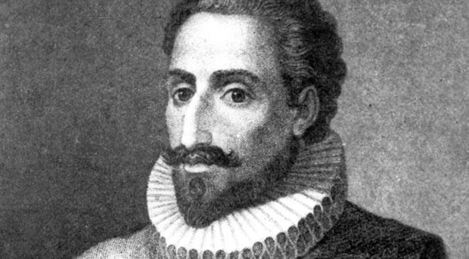
Leonardo da Vinci, Italian Renaissance Man

Leonardo da Vinci was born in a village near Florence in 1452. His wide range of interests and accomplishments made him a true Renaissance person.
As a teenager, Leonardo trained in Florence under a master sculptor and painter. All his life he studied many subjects, including art, music, math, anatomy, botany, architecture, and engineering.
Leonardo spent much of his life in Florence and Milan. He worked as an artist, engineer, and architect for kings, popes, and wealthy patrons. A handsome, brilliant man, he had a special love of animals. Sometimes he bought caged animals at the market and set them free. He also was a vegetarian, which was quite unusual for the time.
Leonardo was gifted in many fields. He was an accomplished painter, sculptor, architect, engineer and inventor Leonardo’s notebooks show him to be one of the greatest creative minds of all time. Like Albrecht Durer, he closely studied proportions. He made precise drawings of people, animals, and plants. He also sketched out ideas of geometry and mechanics. He designed weapons, buildings, and a variety of machines. Many of his inventions he drew, such as a helicopter and a submarine, were centuries ahead of their time.
Leonardo’s paintings are among the greatest works of art in the world. One of his masterpieces is the Mona Lisa, a painting of a woman with a mysterious smile. It is one of the most famous paintings in the world. Like his other paintings it displays a remarkable use of perspective, balance, and detail. The rich effects of light, shade, and color reveal Leonardo’s close study of light. Students of his art also detect how principles of geometry helped him organized the space in his paintings.
Leonardo’s art inspired other great artists, such as Michelangelo. With his many interests and talents, Leonardo is a nearly perfect example of the spirit of the Renaissance.

