Document A

Source: Martin Luther King, Jr. “I Have a Dream” Speech. August 28, 1963

I still have a dream. It is a dream deeply rooted in the American dream.

I have a dream that one day this nation will rise up and live out the true meaning of its creed, “We hold these truths to be self-evident, that all men are created equal.”

I have a dream that one day on the red hills of Georgia, sons of former slaves and the sons of former slave owners will be able to sit down together at the table of brotherhood.

I have a dream that my four little children will one day live in a nation where they will not be judged by the color of their skin but by the content of their character.

With this faith we will be able to work together, to pray together, to struggle together, to go to jail together, to stand up for freedom together, knowing that we will be free one day.

Document B

Source: Harvard Press (Image of March on Washington - August 28, 1963)

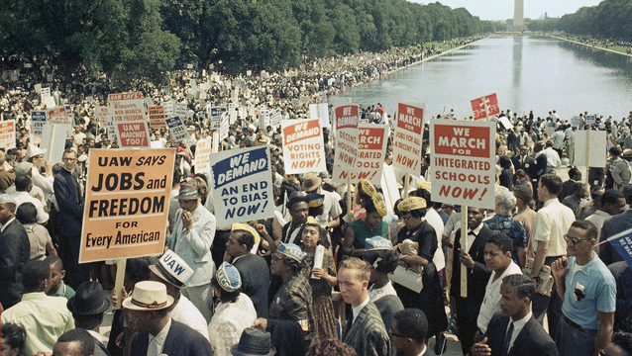

Document C

Source: Economic Policy Institute, 2012

