DOCUMENT 1
Nationalism

Definition: Extreme pride in one’s nation or state. Often seen by the use of flags, national anthems, and other signature items.

Connection leading up to World War One: Nationalism is a long-term cause of WWI. As many of the other causes, nationalism takes time to create. People are not born with the love of their country and land instilled within them; instead, they must learn to love it. This requires a longer period of time to complete; thus, it is a long-term cause.

Germany was extremely proud of the military power that they had become after the Franco-Prussian War. As a new unified nation after January of 1871, the Germans felt nearly unstoppable as a world power.

The French on the other hand had been embarrassed by the Germans and found it necessary to regain their pride. These feelings of resentment led to the massive militarism between these two nations.

Also with the growth of Pan-Slavism or the unification of all Slavic peoples, protected by Russia, the areas around Serbia became very unstable. The Serbians were prepared to create their own independent Slavic state supported by the Russians. This will lead to what we call the “Balkan Powder Keg” or an area in the Balkans that would only take a minor issue to explode into full on war.

DOCUMENT 2
Nationalism

At the settlement of the Congress of Vienna in 1815, the principle of nationalism was ignored in favor of preserving the peace. Germany and Italy were left as divided states, but strong nationalist movements and revolutions led to the unification of Italy in 1861 and that of Germany in 1871. Another result of the Franco-Prussian War of 1870-1871 was that France was left seething of the loss of Alsace-Lorraine to Germany, and Revanche was a major goal for the French. Nationalism posed a problem from Austria-Hungary and the Balkans, areas compromised of many conflicting national groups. The ardent Panslavism of Serbia and Russia’s willingness to support its Slavic brother conflicted with Austria-Hungary’s Pan-Germanism.

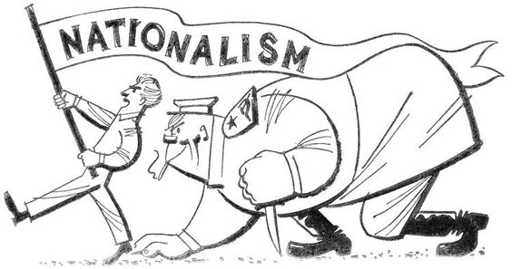

DOCUMENT 1
European Imperialism in the 19th Century

Imperialism is empire building. Expansion occurs when one state is more powerful than are the obstacles of expansion. The obstacles may be other states or people, or they may be the geographic or physical or technical obstacles.
The central core of the empire may be a nation-state, or in ancient times, a city-state or a tribe.
European civilization experienced a period of unprecedented rapid expansion around the globe during the last third of the 19th century. European nation-sates had become very powerful because of industrialization and because of the organizational efficiency of the nation state.
European global expansion had actually begun in the 15th century, but the process greatly accelerated the 19th century.
Latin America and the seaports of Asia and Africa were the first to be colonized by Europeans. Native Americans were liquidated or thoroughly subjugated to European rule. Most Latin American descendants of the Spanish conquerors gained independence from Spain by the early 19th century, while many indigenous peoples remained subject.
The African climate, disease, and geography delayed most European colonization until the 19th century, although the descendants of Dutch settlers, known as Afrikaans or Boers, came to South Africa as early as the 16th century.
Slavery took a heavy toll on African development ever since the 16th century. Millions f young people of working age were taken away. Great conflict ensued.
Asia’s population was too great at its civilization too firmly established for Europeans to rule it directly. The Europeans did establish control over seaports and trade. In places like India and Indonesia, Europeans ruled indirectly through their domination of the local aristocracy.
England was the leading European colonial power and had already established much of its overseas empire by the beginning of the 19th century.
France was second, with its holdings in Southeast Asia and in North Africa, both of these being established during the 19th century.
Portugal, Spain, and Holland retained some colonies because they had been the earliest colonial powers, and still retained some of them in the 19th century.
Germany and Italy were late arrivals on the colonial scene because they had only unified themselves in the 1860s.
The United States became a colonial power at the end of the 19th century, after having spent the century moving across North America and into the Pacific. Defeat of Spain and in the Spanish American War led to the establishment of American colonies in the Caribbean and the Philippines. The Hawaiian Islands were conquered at the same time.
Japan was the first Asiatic nation to become a colonial power. Long isolated and refusing to trade with Europeans, the Japanese were forced to trade by a United States naval squadron in 1845. Subsequently, the Japanese experienced a political revolution. The new leadership modernized rapidly by adopting European technology and organization.
The British forced China to open itself to the Opium trade in the 1840s. China also experienced social upheaval, and was unable to prevent foreign domination of its trade. By the end of the 19th century, England, Germany, Russia, Japan, and the United States had all compelled China to trade with them. Russia occupied Manchuria and Port Arthur, Japan was in Korea, Germany was in the Shantung peninsula, and the British were in Hong Kong.
The French, The British, the Germans, and the Italians competed with each other in the last third of the 19th century to lay claim to Africa. The Belgian king Leopold was also extensively involved. The only remaining areas of Africa not colonized by the end of the century were Ethiopia and Liberia.
Another aspect of European expansion in the last half of the 19th century involved emigration of large numbers of Europeans to other parts of the world. European population had been increasing more rapidly than non-European populations during this time. Population pressure combined with improved overseas transportation led to the greatest migration in history up to that time. The east with which Europeans dominated the non-European world is explained by the power they had resulting from industrialization and national state organization.
But the explanations that Europeans made to themselves were that they were superior to non-European peoples. There were a number of racist ideas widely believed by Europeans:
- Whites were superior to non-whites. One variation was Rudyard Kipling’s idea of the White Man’s Burden. The white man had the burden and responsibility of bringing the blessings of their superior civilization to the savages of the non-European world.
- Another was a variation of social Darwinism in which white Europeans were considered more fit in the struggle for survival.
- Another variation was the Christianity was the only true religion.

DOCUMENT 2
Rudyard Kipling, The White Man’s Burden 1899

Take up the White Man’s Burden-
Send forth the best ye breed-
Go bind your sons to exile
To serve your captives’ need;
To wait in heavy harness,
On fluttered fold and wild-
Your new-caught, sullen peoples,
Half devil and half child.

Take up the White Man’s Burden-
In patience to abide,
To veil the threat of terror
And check the show of pride;
By open speech and simple,
An hundred times make plain
To seek another’s profit,
And work another’s gain.

Take up the White Man’s Burden-
The savage wars of peace
Fill full the mouth of famine
And bid the sickness cease;
And when your goal is nearest
The end for others sought,
Watch sloth and heathen folly
Bring all your hopes to nought.

Take up the White Man’s burden-
No tawdry rule of kings,
But toil of serf and sweeper-
The tale of common things.
The ports ye shall not enter,
The roads ye shall not tread,
Go mark them with your living,
And mark them with your dead.

Take up the White Man’s Burden-
And reap his old reward:
The blame of those ye better,
The hate of those ye guard-
The cry of hosts ye humour
(Ah, slowly!) toward the light-
“why brought he us from bondage,
Our loved Egyptian night?”

Take up the White Man’s Burden-
Ye dare not stoop to less-
Nor call too loud on freedom
To cloke your weariness;
By all ye cry or whisper,
By all ye leave or do,
The silent, sullen peoples
Shall weigh your gods and you.

Take up the White Man’s Burden-
Have done the childish days-
The lightly proferred laurel,
The easy, ungrudged praise.
Comes now, to search your manhood
Through all the thankless years
Cold, edged with dear-bought wisdom,
The judgment of your peers.

DOCUMENT 3
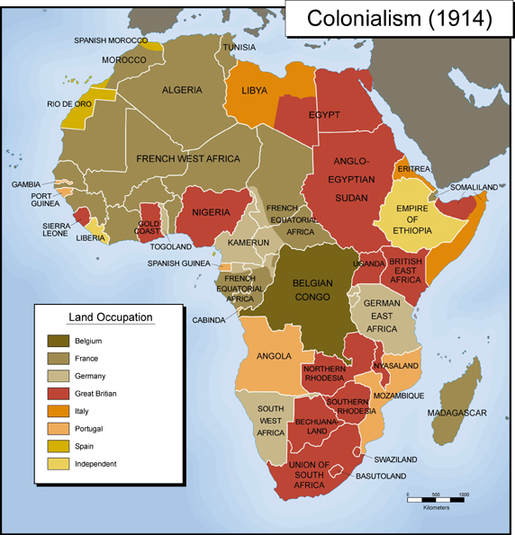

DOCUMENT 4
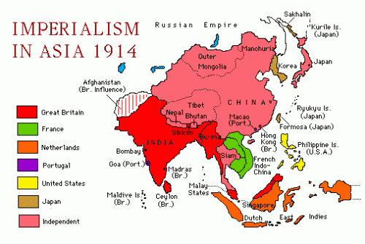

DOCUMENT 1
The Industrial Revolution

The Industrial Revolution began in Great Britain in the 18th century, with a new approach to production, which was required because the accumulation of raw materials was beginning to surpass the ability to produce marketable goods. Industrialism began when Britain became overstocked with raw wool and cotton. The traditional methods of piece work, in which one woman (the traditional producer of cloth) spun thread by hand on a spindle or a wheel, and then wove the thread into cloth, could not keep up with the abundance of raw fiber. The first invention of the industrial age was the Flying Shuttle in 1733, which dramatically sped up the weaving process. This led to the need for more thread; in 1768 the first mechanized spinning device was created, the Spinning Jenny. Power for these devices was still provided by humans. In 1769 the Water Frame was invented, a water powered loom, and in 1787 the Power Loom first appeared, which use either water or animal power.
The gradual industrialization of the cloth industry, which continued to get faster as more thread was spun and woven by ever-larger machines, was the basic scenario of industrialization. The next remarkable innovation was the steam engine in 1769. Steam engines, fueled by coal, were first used to pump water out of mines, then to power machinery, then finally to move goods and people. The railroads probably produced the most conspicuous result of the Industrial Revolution. How the West understood distance and time would never be the same.
Industrialism began in Britain for several reasons. Of all the countries of Europe, Britain alone possessed more of the necessary ingredients. Britain had a ready supply of labor, pre-existing access to transportation via roads and canals, a stable government natural resources, and finally, wealth and markets.
While industrialism may have begun in Britain, it quickly moved to the European continent and the Americas. Not all states industrialized at the same time or to the same extent as Britain, who was the world’s leading industrialized power until the early 20th century.

DOCUMENT 2
Charles Dickens, from Hard Times

It was a town of red brick, or of brick that would have been red if the smoke and ashes had allowed it; but as matters stood it was a town of unnatural red and black like the painted face of a savage. It was a town of machinery and tall chimneys, out of which interminable serpents of smoked trailed themselves forever and ever, and never got uncoiled. It had a black canal in it, and a river that ran purple with ill-smelling dye, and vast piles of building full of windows where there was a rattling and a trembling all day long, and where the piston of the steam-engine worked monotonously up and down, like the head of an elephant in a state of melancholy madness.

It contained several large streets all very like one another, and many small streets still more like one another, inhabited by small equally like one another, who all went in and out at the same hours, with the same sound upon the same payments, to do the same work, and to whom everyday was the same as yesterday and tomorrow, and every year the counterpart of the last and the next.

These attributes of Coketown were in the main inseparable from the work by which it was sustained; against them were to be set off, comforts of life, which found their way all over the world, and elegances of life which made, we will not ask how much of the fine lady, who could scarcely bear to hear the place mentioned. The rest of its features were voluntary, and they were these.

You saw nothing in Coketown but what was severely workful. If the members of a religious persuasion built a chapel there- as the members of eighteen religious persuasions had done- they made it a pious warehouse of red brick, with sometimes (but this is only in highly ornamented examples) a bell in a bird-cage on the top of it. The solitary exception was the New Church; a stuccoed edifice with a square steeple over the door, terminating in four short pinnacles like florid wooden legs. All the public inscriptions in the town were painted alike, in severe characters of black and white.

The jail might have been the infirmary. The infirmary might have been the jail, the town-hall might have been either, or both or anything else, for anything that appeared to the contrary in the graces of their construction. Fact, fact, fact, everywhere in the material aspect of the town; fact, fact, fact, everywhere in the immaterial. The M’Choakumchild school was all fact, and the school of design was all fact, and the relations between master and man were all fact, and everything was fact between the lying-in hospital and the cemetery, and what you couldn’t state in figures, or show to be purchasable in the cheapest market and saleable in the dearest, was not, and never should be, world without end, amen.

DOCUMENT 1
Militarism

Definition: Militarism is the glorification of one’s military. It is also the belief of a nation or its people to build and maintain a strong military, with the intention to use it whenever it is felt necessary.

Connection leading up to World War I: Militarism was a long term cause of the war; due to the length of time it takes a country to build its military to the strength necessary to wage a major war.

Stemming from the invasion of German-speaking peoples lands near the Rhine River by Napoleon during the Napoleonic Wars and the Franco-Prussian War, Otto von Bismarck made it his goal to keep the unified German State prepared to defend itself against France. He felt that it was necessary to keep France isolated and weak at all cost.

Understanding that Germany was building a large military saw it as a necessity to in turn build a large military to protect themselves against the Germans. Thus, these two nations were building massive military strength to use against each other. The Germans were also threatening the British by building a large navy, making the British feel insecure about their place among the world’s elite navies for the first time in nearly a hundred years.

Thus, the British would have to respond to this growing threat as well, by building a larger navy. Though these were not the only countries building and perfecting their arsenal, they were the most significant prior to the outbreak of WWI. It does not take long for these countries to find a reason to use their militaries against each other in an attempt to prove who is superior.

DOCUMENT 2
An effect of the Franco-Prussian War

The militaristic fever that preceded WWI stemmed largely from the Franco-Prussian War, a conflict between Germany and France during 1870 and 1871. The Germans sadly beat the French on French soil. In the ensuing peace, Germany received the French provinces of Alsace and Lorraine, a precarious peace for the remainder of the 19th century.
German victory during the Franco-Prussian War was not due to brilliant leadership, or brilliant tactics, or swift maneuvers. Rather, German victory was due to superior military organization and the superior military education of its army. The war had shown that a small professional was no longer an effective fighting force and that any continental power that wanted to escape annihilation had better imitate the German model and create a Nation in Arms.
As a result, by the eve of WWI, Europe had become a continent of Nations in Arms.

The Consequences of Militarism

As the powers of Europe grew increasingly militarized, they also became every more anxious. Nations, especially Germany, came to assume that military strength must be the chief factor in national preservation and that the military class should be the most revered class in society.
These militaristic convictions came to wreak havoc on the 20th century. Unfortunately, even more Americans today, we have not discarded this false faith in military power and in military institutions.

Why the Military Calls the Shots

Once Europe entered the age of the million-man army, each country’s army developed a general staff system in which military technicians made war plans, mobilized schedules, logistical schemes, schedules of weapons development and testing, and a plethora of other systems that were bewildering and baffling for the layman. The military had become too complicated for the politicians to understand, let alone control. The military had freed itself from civilian supervision.
The great tragedy in all of this was that if the military men were ever going to demonstrate their skill and accomplishments, they would have to go to war. In addition, anybody devoting their life to warfare was going to be inclined to think of war as a solution to national and diplomatic problems.
Consequently, in times of crisis, as national leaders called military leaders into policy conferences, the military leaders could be counted on to demand the immediate implementation of their military plans and to argue that peaceful alternatives would spell disaster. Civilian statesmen were finding it difficult to prevent the military from taking over their decision-making function.

How Militarism was a Cause of WWI

By 1914, most governments were under pressure from their militaries to act more precipitously than the heads of state thought advisable. Hence, diplomatic machinery found itself powerless to find a solution to the crisis of 1914.

