Period 1 (1491-1607)
This period accounts for roughly 5% of the exam. Although you will not see a Long Essay or DBQ based solely on this time period, you could see a topic that incorporates this period as part of a larger idea.

1491 marks one year prior to the arrival of Columbus and Europeans in large numbers to the Americas. Additionally, 1607 is the year that the first permanent English settlement was established in Jamestown, Virginia. Period 1 focuses significantly on Native American life PRIOR to the arrival of Europeans. Furthermore, impacts of the Columbian Exchange on Africans, Native Americans, and Europeans are important to know

Key vocabulary terms to know for this time period:

Autonomy - to have self-government, or independence. Native Americans and Africans sought to preserve autonomy in the face of contact with Europeans.
Subjugation - to take control of a person or group of people by force. Native Americans and Africans were subjugated by Europeans, often in the form of slavery.
Maize - corn, grown in present-day Mexico and spread to the Southwest portion of the present-day United States. Native Americans built societies around maize. Once it was introduced to Europe (Columbian Exchange), it helped lead to a drastic increase in population.
Columbian Exchange - Spread of goods, ideas, people, and diseases between Africa, Europe, and the Americas.
Encomienda System - Spanish system of granting land to colonists in the New World. This system exploited Native Americans and resources. Eventually, Native American labor was replaced with African slave labor.

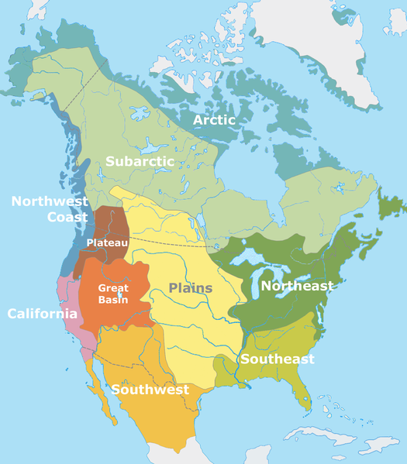

- For each region listed below based on the map, describe what Native American life was like: Great Plains/Great Basin, Southwest, Northeast

- What technological improvements allowed for European exploration?
- What impact did the Columbian Exchange have on Europe?
- What impact did the Columbian Exchange have on Native Americans?
- What impact did the Columbian Exchange have on Africans?
- How did Europeans view natives?

“The Spanish have a perfect right to rule these barbarians of the New World and the adjacent islands, who in prudence, skill, virtues, and humanity are as inferior to the Spanish as children to adults……”
- Juan De Sepulveda (1547)

- What is Sepulveda’s point of view towards Natives?
- How does this view contrast with Bartolome de las Casas

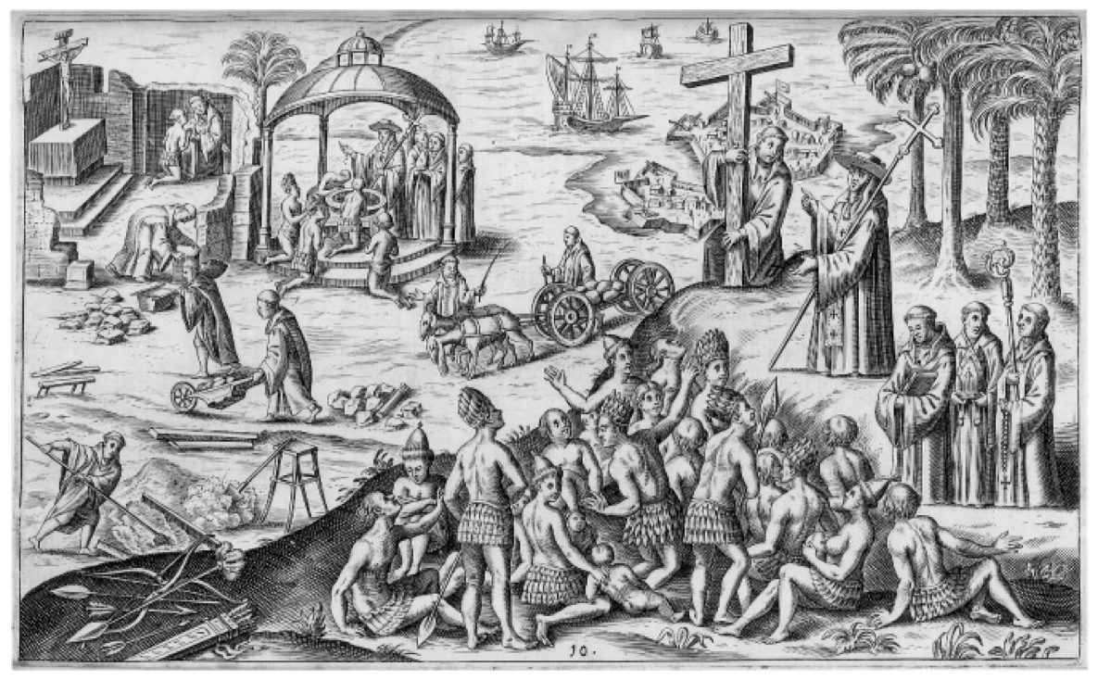

- What is the Point of View of Spanish Colonization according to the illustration?

Period 2 (1607 – 1754)
Welcome to Period 2! This period accounts for roughly 10% of the exam.1607 marks the beginning of the establishment of permanent English colonies with Jamestown, Virginia in 1607. England became a significant colonizer during this time period and competed with other European countries. Furthermore, 1754 marks the beginning of the 7 Years War (French and Indian) predominantly between the English and the French.

Key vocabulary terms to know for this time period:

Characteristics of Spanish colonization - focused on converting Natives and gaining wealth through tight control over colonies. (Think 3 Gs - period #1)
Characteristics of French and Dutch colonization - fewer inhabitants than other countries. The French and Dutch focused on trade (especially fur), alliances, and intermarriage with Native Americans.
Characteristics of English colonization - colonies were based on agriculture. English colonies saw a large number of men AND women inhabit the colonies. The English had relatively hostile relations with Native Americans.
Pueblo Revolt - Native American revolt in the late 17th century in present-day New Mexico against the Spanish. The Spanish were expelled for over 10 years. Once they regained control, the Spanish began to take a more accommodating approach to Natives and allowed some religious accommodation.
The Enlightenment - Time period that focused on reason and knowledge and promoted new ideas about government (natural rights, consent of the governed, separation of powers). These ideas helped influence the American Revolution.
Mercantilism - Economic policy that focuses on making money for the mother country. This policy favors a positive balance of trade for the mother country and the accumulation of gold and silver.
Anglicization - Process of colonies becoming and acting British. This was influenced by print culture (newspapers and writings) and communities based on English models.
Characteristics of New England colonies - founded by mostly Puritans, a group of like-minded individuals. These colonies tended to be close-knit and had longer life expectancies than other English colonies. The economy was a mix of farming and trade.
Characteristics of middle colonies - These colonies were the most diverse religiously and saw the most immigrants from Europe. The economy was based on grain.
Characteristics of southern colonies - The Chesapeake (Maryland and Virginia) relied on indentured servants initially, later replaced by African slaves. Staple crops like tobacco, rice, and sugar made the colonies prosperous.

1. For each of the following countries, provide a brief summary of the goals/characteristics of colonization in the Western Hemisphere. Please make sure you include the DEMOGRAPHICS – makeup of the population. Want more info?
- Spain:
- Dutch and French:
- English
2. . How did characteristics of British colonization differ from Spanish colonization?

3. What were three reasons for the development of the slave trade?
4. What is Mercantilism? How did colonists get around this policy?
5. How did the Enlightenment encourage colonial resistance?
6. What were three reasons for the growth of slavery?
7. Why did African Slavery replace indentured servitude in the English colonies AFTER 1676? (Turning Point in American History)
8.Complete the table below on the characteristics English colonial regions. (Think politics, economics, religion, demographics, labor systems, etc.

Chesapeake | Both | New England

“Be it enacted ... no goods or merchandizes whatsoever shall be imported into, or exported out of, any colony or plantation to his Majesty, in Asia, Africa, or America ... in any ship or bottom, but what is or shall be of the built of England, Ireland, or the said colonies or plantations ... and navigated with the masters and three fourths of the mariners of the said places only ... under pain of forfeiture of ships and goods.” Navigation Act, April 1696
1. What is the Purpose of this Act?
3. What are implications of England loosely enforcing this law? (Think long-term consequences…..)
Period 3 (1754 – 1800) Review Sheet
This period accounts for roughly 12% of the exam. In past exams, this period has been a popular choice for essays and Short Answer Questions, so make sure you are able to explain main ideas. 1754 marked the beginning of the 7 Years War (French and Indian) which the British would win and end its longstanding policy of salutary neglect. 1800 marked the election of Thomas Jefferson, which some historians have called The Revolution of 1800.

Key vocabulary terms to know for this time period:
Impact of the 7 Years’ War - France was removed from North America; Great Britain was in massive debt, began to consolidate control over colonies - taxes; many colonists resisted
Common Sense - Written by T-Paine, and Enlightenment thinker. Urged that it was "Common Sense" that colonies should break away from Great Britain
Declaration of Independence - Inspired by Common Sense and Enlightenment ideals; inspired France and countries in Latin America to experience revolutions
Reasons for Patriot Victory in the Revolutionary War - Colonists' familiarity with the land; political and military leadership (Washington); ideological commitment (Natural Rights); Support from European Allies (France after Saratoga)
Northwest Land Ordinance - Passed under Articles - banned slavery in NW territory (OH, MI, IN, etc.); created a process for admitting new states (60,000 inhabitants)
A rticles of Confederation - First governing document of US - created a WEAK central government; issues with trade - different currencies in each state, tariffs on goods traded between states
Constitution - Replaced the Articles - series of compromises (Great, 3/5, Slave Trade); provided limits on federal power (separation of powers); did not address problems of slavery
Washington’s Farewell Address - Warned of entangling foreign alliances and political parties; helped inspire foreign policy until after WWII
Republican Motherhood - Expectation that women would instill Republican values in children and be active in families; helped increase education for women
Bill of Rights - Added AFTER the Constitutional Convention; created to gain support of anti-Federalists; guaranteed rights of individuals

- How did the 7 Years’ War impact the French?
- Identify and define three examples of salutary neglect ending after the 7 Years War.
- What was the message of Thomas Paine’s Common Sense?
- What were three reasons the Patriots were successful in the Revolutionary War?
- Why was the Articles of Confederation purposely created to be weak?
- What was the significance of the Northwest Land Ordinance?
- Describe the following compromises that are found in the Constitution.
  - Great Compromise
  - 3/5 Compromise
  - Slave Trade Compromise
- What were 5 parts of Alexander Hamilton’s Financial Plan?

- Complete the following table below about the First Party System.
 | Democratic-Republicans | Federalists
Foreign Policy Favored This Country
View of the National Bank (BUS)
Interpretation of the Constitution
People that supported this party were likely to be
Economy should be based on

- How did Republican Motherhood help define the role of women after the Revolutionary War?
“And We do hereby strictly forbid, on Pain of our Displeasure, all our loving Subjects from making any Purchases or Settlements whatever…… without our especial leave and Licence for that Purpose first obtained. And We do further strictly enjoin and require all Persons whatever who have either willfully or inadvertently seated themselves upon any Lands ……. to remove themselves from such Settlements.”
Proclamation Line of 1763

- What was the reaction to this document?
- What was the cause of this document?
- What were the effects of this document?
- What was the Purpose of this document?
- Who is the Intended Audience of this document?

“Small islands, not capable of protecting themselves, are the proper objects for kingdoms to take under their care; but there is something absurd, in supposing a continent to be perpetually governed by an island.”
- Common Sense, 1776

- What is the Historical Context of the document?
- Who is the Intended Audience of the document?

Period 4 (1800-1848)
This period accounts for roughly 10% of the exam. In past exams, this period has been a popular choice for essays and Short Answer Questions, so make sure you are able to explain main ideas.
1800 marked the election of Thomas Jefferson, which some historians have called The Revolution of 1800. 1848 is the year the Seneca Falls Convention occurred and was also the year the Mexican-American War ended.

Key vocabulary terms to know for this time period:
Impact of the Supreme Court decisions of the early 1800s - The primacy of the judiciary in determining the meaning of the Constitution (think judicial review)) and giving federal laws power over state governments (think Gibbons v. Ogden and McCulloch v. Maryland)
Whigs and Democrats Disagreed over - Role and powers of the federal government, National Bank, tariffs, federally funded internal improvements (Think Henry Clay's American System)
Impact of the Second Great Awakening - Moral and social reforms (think abolitionism, women's rights, temperance, etc.)
Seneca Falls Convention- Women's Rights convention that sought greater equality (attended by men too such as Frederick Douglass)
New innovations during the Market Revolution - Textile machinery (spinning jenny), steam engines, interchangeable parts (Eli Whitney), telegraph, and agricultural inventions (cotton gin - Whitney again) ow did the Market Revolution change the production of goods? - Goods were increasingly made outside the home. Women and men began working in factories.
Where did immigrants settle? - Irish settled in northern cities, Germans settled on the frontier - worked as farmers (CINCINNATI!)
American System - Henry Clay’s plan to unify the American economy. Focused on a 2nd BUS, Internal Improvements, and Tariffs. The north and Midwest benefitted more than the south.
Monroe Doctrine - President Monroe's message to Europe to NOT colonize any new land in Latin America. The US would stay out of European affairs.
Missouri Compromise (Compromise of 1820) - 3 parts: Maine was a free state, Missouri was a slave state, everything above 3630 latitude line would be free, everything below would be slave. This applied to ONLY the Louisiana Purchase. Later overturned by the Kansas-Nebraska Act (possible synthesis point).

- What was the significance of Marbury v. Madison?
- What were reasons for the growth of the Second Party System? (Democrats and Whigs).
- Complete the chart below based on the Democrats and Whigs.
 | Democrats | Whigs
Role and Power of Federal Government
View of the National Bank (2nd BUS)
View of Tariffs
View of Federally funded Internal Improvements

- Identify and briefly explain three impacts of the Second Great Awakening?
- What was the goal of the Seneca Falls Convention? Did they achieve this goal?
- Identify and briefly explain two new technological innovations ruing the Market Revolution
- What was the goal of Henry Clay’s American System? Was it successful?
- What was the message of the Monroe Doctrine?
- How were Native Americans impacted as a result of westward expansion
- What were the three parts of the Missouri Compromise? Why was it important for both the North and South to have the balance of states equal at 12?
- What two groups immigrated in large numbers to America in the 1830s and 1840s? Where did they tend to settle?
- What happened to the amount of Americans able to vote under Andrew Jackson’s Presidency? What groups were still not able to vote?

“I am aware that many object to the severity of my language; but is there not cause for severity? I will be as harsh as truth, and as uncompromising as justice. On this subject, I do not wish to think, or speak, or write, with moderation. No! No! Tell a man whose house is on fire to give a moderate alarm; tell him to moderately rescue his wife from the hands of the ravisher; tell the mother to gradually extricate her babe from the fire into which it has fallen;—but urge me not to use moderation in a cause like the present. I am in earnest—I will not equivocate—I will not excuse—I will not retreat a single inch—AND I WILL BE HEARD. The apathy of the people is enough to make every statue leap from its pedestal, and to hasten the resurrection of the dead.”
— William Lloyd Garrison, "To the Public," from the Inaugural Editorial in the January 1, 1831, issue of The Liberator
(Check out THIS video that breaks down the above document.)

- How does Garrison justify his approach towards slavery?
- What were arguments used by the South to counter Garrison’s message?

“[T]his momentous question, like a firebell in the night, awakened and filled me with terror. I considered it, at once as the [death] knell of the Union. It is hushed, indeed, for the moment. But this is a reprieve only, not a final sentence. A geographical line, coinciding with a marked principle, moral and political, once conceived and held up to the angry passions of men, will never be obliterated; and every new irritation will mark it deeper and deeper.”
-- Source: Thomas Jefferson to John Randolph, April 22, 1820
(Check out THIS video that breaks down the above document)

- What is the Purpose of this document?
- . What is the Historical Context of this document

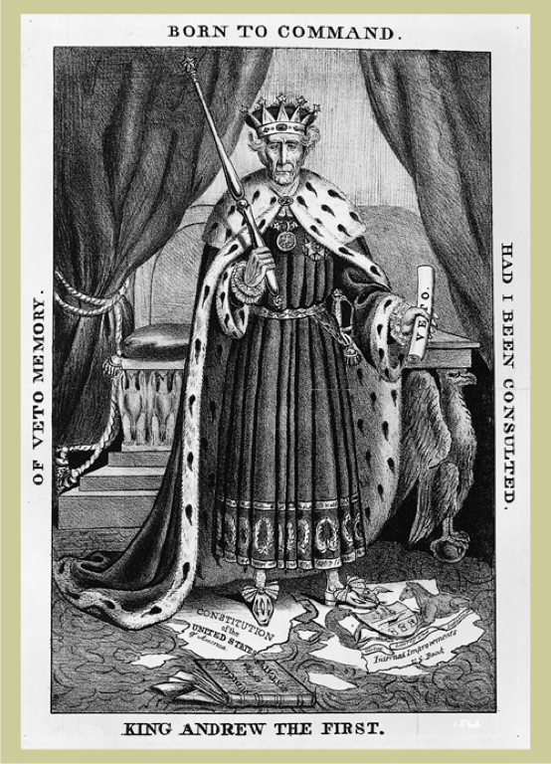

- What political party would support the image above?
- Would the following people/groups agree or disagree with the depiction of Andrew Jackson in the image? Why?
  - Native Americans such as the Cherokees:
  - Individuals that opposed the BUS:
  - John C. Calhoun

“The committee [of the South Carolina Legislature] have bestowed on the subjects referred to them the deliberate attention which their importance demands; and the result, on full investigation, is a unanimous opinion that the act of Congress of the last session, with the whole system of legislation imposing duties on imports, not for revenue, but the protection of one branch of industry at the expense of others, is unconstitutional, unequal, and oppressive, and calculated to corrupt the public virtue and destroy the liberty of the country; which propositions they propose to consider in the order stated, and then to conclude their report with the consideration of the important question of the remedy.”
-- South Carolina Exposition and Protest, 1828

- What issue does the South Carolina legislature have with Congress?
- Does this document support the American System? How do you know?
- Who is the Intended Audience of this document?

Period 5 (1844 – 1877)
1844 marked the election of James K. Polk. Shortly after his election, Manifest Destiny was in full thrust as well as the Mexican-American War. Many have argued that this war was a Turning Point. After the Civil War ended, the US entered a time period known as Reconstruction, which ended in 1877.

Key vocabulary terms to know for this time period:
Reasons for westward migration (Manifest Destiny) - Access to natural and mineral resources, economic opportunities for settlers, religious refuge (Mormons).
Arguments to annex western lands included – Manifest Destiny and American institutions (democracy)
Impact US acquiring the Mexican Cession- Debates over the status of slavery (Wilmot Proviso), Native Americans, and Mexicans in the newly acquired land.
How did the government encourage westward migration?- Passing new legislation (think Homestead Act) encouraging settlers to move west, government gave land and subsidies to RR companies.
Goal of the Nativist Movement? - It was especially Anti-Catholic. The nativists hoped to limit the power and cultural influence of the immigrants (Irish and Germans).
What was the free soil movement? - Sought to keep slavery from expanding into newly acquired territories.
What were ways abolitionists campaigned against slavery? - Moral arguments (think William Lloyd Garrison), assisting slaves' escapes (think Underground RR), using violence (think Bleeding-Kansas and Harpers Ferry).
How did the South justify and defend slavery? – They claimed slavery was a positive good (John C. Calhoun).
What was the Compromise of 1850? - Dealt with the Mexican Cession – popular sovereignty would be used in the territory, slave trade was banned in Washington D.C., California was added as a free state, a more strict fugitive slave law was created.
What was the Kansas-Nebraska Act? - Overturned the MO Compromise - introduced popular sovereignty in Kansas and Nebraska. Helped lead to the creation of the Republican Party.
What did the Supreme Court rule in Dred Scott v. Sanford? – Slaves were property, not citizens; Congress could NOT legislate slavery in the territories.
What did Lincoln campaign on in the Election of 1860? – A free soil platform – non extension of slavery.
How did Lincoln’s views towards the war change over time? – Lincoln viewed the war initially as preserving the union, but eventually sought to end slavery -> Emancipation Proclamation and Gettysburg Address
How did the Union ultimately prevail in the Civil War? – Improvements in leadership and strategy (Grant and the “Anaconda Plan”), Key Victories – Gettysburg and Antietam; Greater resources – more factories and RRs, the South’s infrastructure was destroyed.
What did the 13 – 15 amendments do? – 13 – abolished slavery; 14 – granted citizenship and equal protection; 15 – universal adult male suffrage.
Why did the 15th amendment split the women’s rights movement? – Some women advocated suffrage be extended to women as well as African American males.
Why did Reconstruction end? – Compromise of 1877 withdrew troops from the South; The North’s WANING resolve led to many in the North to no longer support Reconstruction.
What is sharecropping? – Renting of land to former slaves – limited economic opportunities to former slaves and poor whites in the south.
What were ways the South resisted the 14th and 15th amendments? (Great Short Answer Question) – Segregation – Jim Crow laws; Violence – KKK and White League; Supreme Court Decisions – Plessy v. Ferguson (“Separate but equal”); Local political tactics – poll taxes, literacy tests, and grandfather clauses

- What is MANIFEST DESTINY?
- How did territorial expansion lead to debates over slavery? (Need SPECIFIC historical evidence)
- How did the government encourage westward expansion during the time period
- What were three ways abolitionists sought to achieve their goals?
- How did the Mexican-American War contribute to tensions between the north and south?
- How did the South defend slavery?
- Briefly explain how each of the following contributed to tensions over slavery:
- Compromise of 1850:
- Kansas-Nebraska Act:
- Dred Scott decision:
- What impact did the Emancipation Proclamation have on the Civil War?
- What were three reasons the Union succeeded in the Civil War?
- Please describe the following Amendments: 13, 14, 15
- What impact did the 15th amendment have on the women’s rights movement?
- What are examples of African Americans gaining political opportunities during Reconstruction?
- What were three ways Southern states limited the rights of African Americans?
- Why did “Radical” Reconstruction occur?

“Provided, That, as an express and fundamental condition to the acquisition of any territory from the Republic of Mexico by the United States, by virtue of any treaty which may be negotiated between them, and to the use by the Executive of the moneys herein appropriated, neither slavery nor involuntary servitude shall ever exist in any part of said territory, except for crime, whereof the party shall first be duly convicted.”
- Wilmot Proviso, 1846

- What was the goal of the Wilmot Proviso?
- How would the following view the Wilmot Proviso?
- Southern Plantation Owners:
- Supporters of Popular Sovereignty:
- Members of the Free-Soil Party:
- Members of the Republican Party:

