Short Answer
Three questions, 40 minutes, 20% of Exam Score

You will have a choice between two options for the final required short answer questions, each one focusing on a different time period.

Question 1 (required): periods 3-8
Question 2 (required): periods 3-8
Choose between Question 3, periods 1-5 and Question 4, periods 6-9

Scoring Guide:
0-3 points
- Score 3
  - Response accomplishes all three tasks set by the question
- Score 2
  - Response accomplishes two of the tasks set by the question
- Score 1
  - Response accomplishes one of the tasks set by the question
- Score 0
  - Response accomplishes none of the tasks set by the question
- Score NR
  - No response.

Short Answer Question 1:
- Briefly explain how ONE specific historical development represents an accomplishment of the national government under the Articles of Confederation
- Briefly explain how ONE specific argument critics used in the 1780s to support revising the Articles of Confederation
- Briefly explain ONE specific way in which the United States Constitution addresses a criticism of the Articles of Confederation.

Scores:
A: _____ E: _____
B: _____ F: _____
C: _____
D: _____

Short Answer Question 2:
- Briefly explain ONE important way in which the Second World War (1939-1945) transformed the relationship of the United States with the rest of the world.
- Briefly explain ONE important way in which the Second World War transformed United States society.
- Briefly explain ANOTHER important way in which the Second World War transformed United States society.

Scores:
A: _____ E: _____
B: _____ F: _____
C: _____
D: _____

Short Answer Question 3:
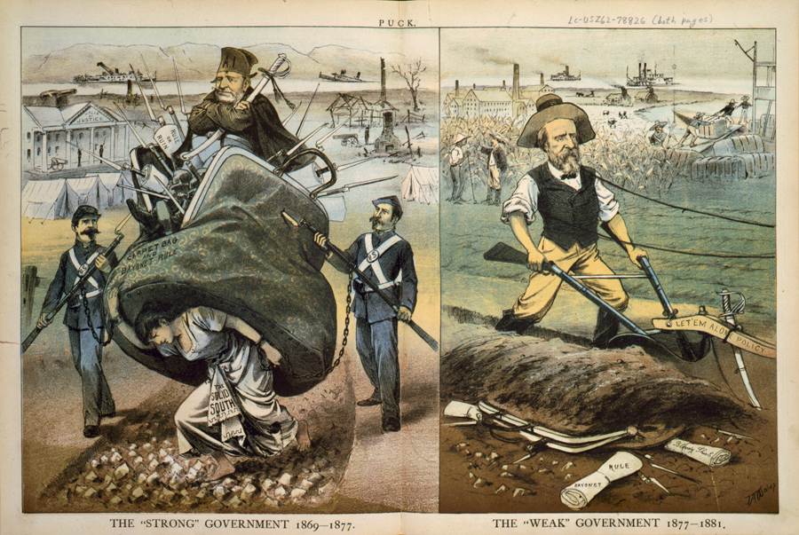

- Briefly explain ONE historical perspective expressed by the artist about the changes from the period of 1869-1877 to the period of 1877-1891
- Briefly explain how ONE specific event or development led to a historical change suggested by the images
- Briefly explain ONE specific result in the period 187-1900 of a historical change suggested by the images.

Scores:
A: _____ E: _____
B: _____ F: _____
C: _____
D: _____

Short Answer Question 4:
“ An arrogant and stubborn faith in America’s power to shape the course of foreign events compounded the dangers sown by ideological rigidity. Policymakers shared a common conviction that the United States not only should, but could, control political conditions in South Vietnam, as elsewhere throughout much of the world. This conviction had led Washington to intervene progressively deeper in South Vietnamese affairs over the years, this conviction prompted policymakers to escalate the war… domestic political pressures exerted an equally powerful … influence over the course of U.S. involvement in Vietnam… Another loss to communism in East Asia risked renewed and devastating attacks from the right
Brian VanDeMark, historian, Into the Quagmire, 1995

“The escalation of U.S. military intervention grew out of a complicated chain of events and a complex web of decisions that slowly transformed the conflict into an American war… President Johnson made the critical decisions that took the U.S. into war almost without realizing it… although impersonal forces influenced the president’s Vietnam decisions, those decisions depended primarily on his character, his motivations, and his relationships with his principal advisers. The war in Vietnam was not lost in the field, nor was it lost on the front pages of The New York Times of on the college campuses. It was lost in Washington D.C., even before American assumed sole responsibility for the fighting
H.R. McMaster, historian, Dereliction of Duty, 1997

- Briefly explain ONE major difference between VanDeMark’s and McMaster’s historical interpretations of the United States involvement in Vietnam.
- Briefly explain how ONE historical event or development in the period 1945-1975 that is not explicitly mentioned in the excerpts could be used to support VanDeMark’s interpretation.
- Briefly explain how ONE historical event or development in the period 1945-1975 that is not explicitly mentioned in the excerpts could be used to support McMaster’s interpretation.

Scores:
A: _____ E: _____
B: _____ F: _____
C: _____
D: _____

